|  |  |
| --- | --- |
|  | **MINISTRY OF**  **EDUCATION AND TRAINING** |

**CAPSTONE PROJECT REPORT**

**Report 4 – Software Design Document**

- Hanoi, December 2021 -

Table of Contents

Acronyms and Definitions 1

Record of changes 1

Report IV. Software Design Description 2

1. System Architecture Design 2

1.1. Overall Architecture 2

1.2. System Architecture 3

1.2.1. Front-end Components 3

1.2.1.1. 3

1.2.1.2. 3

1.2.1.3. 3

1.2.1.4. 3

1.2.1.5. 3

1.2.2. Back-end Components 3

1.2.2.1. Spring Boot 3

1.2.2.2. Json Web Tokens 4

1.2.2.3. 4

1.2.2.4. 4

1.2.3. Database 4

1.2.4. Deployment & Hosting 5

1.2.4.1. VPS (Powered by Nhan Hoa Software Company) 5

1.2.4.2. Github Actions 5

1.3. Package Diagrams 6

1.3.1. Frontend 6

1.3.2. Backend 6

2. Database Design 8

2.1. Table “user” 9

2.2. Table “dietaryinfo” 9

2.3. Table “tbl_catches_detail” 9

2.4. Table “tbl_check_in” 10

2.5. Table “tbl_district” 10

2.6. Table “tbl_employee_list” 10

2.7. Table “tbl_fish_species” 10

2.8. Table “tbl_fish_in_lake” 10

2.9. Table “tbl_fishing_location” 11

2.10. Table “tbl_fishing_method” 12

2.11. Table “tbl_lake” 12

2.12. Table “tbl_lake_fishing_method” 12

2.13. Table “tbl_notification” 12

2.14. Table “tbl_post” 13

2.15. Table “tbl_province” 13

2.16. Table “tbl_report” 13

2.17. Table “tbl_report_user” 14

2.18. Table “tbl_review” 14

2.19. Table “tbl_suggested_location” 14

2.20. Table “tbl_user” 15

2.21. Table “tbl_user_notification” 15

2.22. Table “tbl_user_saved_fishing_locations” 15

2.23. Table “tbl_vote” 15

2.24. Table “tbl_ward” 16

2.25. Table “user_roles” 16

3. Detail Design 17

3.1. Feature “Authenticate user” 17

3.1.1. Class Diagram 17

3.1.2. Sequence Diagram(s) 17

3.1.2.1. Login 17

3.1.2.2. Register 17

3.1.2.3. Forgot password 18

3.2. Feature “Manage personal profile” 18

3.2.1. Class Diagram 18

3.2.2. Sequence Diagram(s) 19

3.2.2.1. View personal profile 19

3.2.2.2. Edit personal profile 19

3.2.2.3. Change password 20

3.2.2.4. Change phone number 20

3.2.2.5. Send OTP 21

3.2.2.6. Validate OTP 21

3.3. Feature “Manage system accounts” 22

3.3.1. Class Diagram 22

3.3.2. Sequence Diagram(s) 23

3.3.2.1. View and search system account list 23

3.3.2.2. View account details 23

3.4. Feature “Search fishing location” 24

3.4.1. Class Diagram 24

3.4.2. Sequence Diagram(s) 24

3.4.2.1. Search and filter nearby fishing location 24

3.4.2.2. Advanced search 25

3.4.2.3. View fishing location’s overview 25

3.4.2.4. View lake list 26

3.4.2.5. View lake details 26

3.4.2.6. Save fishing location 26

3.4.2.7. Report false fishing location information 27

3.5. Feature “Manage fishing location’s reviews” 28

3.5.1. Class Diagram 28

3.5.2. Sequence Diagram(s) 29

3.5.2.1. View fishing location’s review 29

3.5.2.2. Post personal review 29

3.5.2.3. Vote/Downvote review 30

3.5.2.4. Delete personal review 30

3.5.2.5. Report inappropriate review 31

3.6. Feature “Manage check-in” 31

3.6.1. Class Diagram 31

3.6.2. Sequence Diagram(s) 32

3.6.2.1. Verify check-in action 32

3.6.2.2. View personal check-in history 32

3.6.2.3. View and filter fishing location’s check-in history 33

3.7. Feature “Manage catch reports” 33

3.7.1. Class Diagram 33

3.7.2. Sequence Diagram(s) 34

3.7.2.1. Catch details reporting 34

3.7.2.2. View pending catch reports 34

3.7.2.3. Approve/Reject catch detail report 35

3.7.2.4. View personal catch history list 35

3.7.2.5. View and filter fishing location’s catch history 36

3.7.2.6. View catch history detail 36

3.7.2.7. Report inappropriate catch detail report 37

3.7.2.8. Check-out 37

3.8. Feature “Manage fishing location’s profile” 38

3.8.1. Class Diagram 38

3.8.2. Sequence Diagram(s) 38

3.8.2.1. Add a fishing location 38

3.8.2.2. Edit fishing location’s overview 39

3.8.2.3. Add lake 39

3.8.2.4. Close lake 40

3.8.2.5. Edit lake’s profile 40

3.8.2.6. Add fish in lake 41

3.8.2.7. Stock fish in lake 41

3.8.2.8. Delete fish in lake 42

3.8.2.9. Temporary close/reopen fishing location 42

3.8.2.10. Delete fishing location 43

3.9. Feature “Manage system fishing locations” 44

3.9.1. Class Diagram 44

3.9.2. Sequence Diagram(s) 45

3.9.2.1.Verify/Unverify fishing location 45

3.9.2.2. Search and view system fishing location list 45

3.10. Feature “Receive notification” 46

3.10.1. Class Diagram 46

3.10.2. Sequence Diagram(s) 46

3.10.2.1. View list of notifications 46

3.11. Feature “Manage fishing location’s posts” 47

3.11.1. Class Diagram 47

3.11.2. Sequence Diagram(s) 48

3.11.2.1. View fishing location’s posts 48

3.11.2.2. View public catch details as post 48

3.11.2.3. Public fishing location’s post 49

3.11.2.4. Edit fishing location’s post 49

3.11.2.5. Delete fishing location’s post 50

3.11.2.6. Report fishing location’s post 50

3.11.2.7. Pin/Unpin fishing location’s post 51

3.12. Feature “Manage fishing location’s staffs” 52

3.12.1. Class Diagram 52

3.12.2. Sequence Diagram(s) 53

3.12.2.1. View fishing location’s staff list 53

3.12.2.2. Add staff to fishing location 53

3.12.2.3. Remove staf from fishing location 54

3.13. Feature “Manage system reports” 54

3.13.1. Class Diagram 54

3.13.2. Sequence Diagram(s) 55

3.13.2.1. View reports in the system 55

3.13.2.2. View report details 56

3.13.2.3. Mark report as resolved 56

3.13.2.4. Remove reported review 57

3.13.2.5. Remove reported post 57

3.13.2.6. Remove reported catch report 58

3.13.2.7. Activate/Deactive reported fishing location 58

3.14. Feature “Manage system fish species” 58

3.14.1. Class Diagram 59

3.14.2. Sequence Diagram(s) 59

3.14.2.1. View system fish species list 59

3.14.2.2. Add new fish species 60

3.14.2.3. Edit fish species information 60

3.14.2.4. Activate/Deactive fish species 60

3.15. Feature “Manage system fishing methods” 61

3.15.1. Class Diagram 61

3.15.2. Sequence Diagram(s) 61

3.15.2.1. View system fishing method list 61

3.15.2.2. Add new fishing method 62

3.15.2.3. Edit fishing method information 62

3.15.2.4. Activate/Deactive fishing method 62

3.16. Feature “Manage fishing location’s suggestion” 63

3.16.1. Class Diagram 63

3.16.2. Sequence Diagram(s) 64

3.16.2.1. Suggest fishing location 64

3.16.2.2. View list of suggested location 64

3.16.2.3. Mark helpful suggestion form 64

3.16.2.4. Create suggested location 65

3.17. Feature “Manage banned phone number” 65

3.17.1. Class Diagram 65

3.17.2. Sequence Diagram(s) 66

3.17.2.1. View and search banned phone number list 66

3.17.2.2. Ban a phone number 66

3.17.2.3. Unban a phone number 66

# Acronyms and Definitions

|  |  |  |
| --- | --- | --- |
| **#** | **Acronym** | **Definition** |
| 1 | PK | Primary Key |
| 2 | FK | Foreign Key |
| 3 | CI | Continuous Integration |
| 4 | CD | Continuous Delivery |
| 5 | VPS | Virtual Private Server |

*Acronyms and Definitions Table*

# Record of changes

|  |  |  |  |
| --- | --- | --- | --- |
| **Date** | **Status** | **In charge** | **Change description** |
| 11/20/2021 | A | VietNH | Add all heading for report |
| 12/10/2021 | M | VietNH | Complete System Architechture Design |
| 12/13/2021 | M | VietNH | Complete Database Design, Detail Design |

A – Added, M – Modified, D – deleted

# 

# Report IV. Software Design Description

## 1. System Architecture Design

### 1.1. Overall Architecture

Figure 1.1. 4HTN Overall Architecture

### 1.2. System Architecture

#### 1.2.1. Front-end Components

##### 1.2.1.1. ReactJS



Figure 1.2.1.1. “ReactJS” Logo

The React.js framework is an open-source JavaScript framework and library developed by Facebook. It's used for building interactive user interfaces and web applications quickly and efficiently with significantly less code than you would with vanilla JavaScript.

##### 1.2.1.2. NodeJS



Figure 1.2.1.2. “NodeJS” Logo

Node.js is an open-source, cross-platform JavaScript runtime environment and library for running web applications outside the client's browser. Ryan Dahl developed it in 2009, and its latest iteration, [version 15.14,](https://nodejs.org/en/blog/release/v15.14.0/) was released in April 2021. Developers use Node.js to create server-side web applications, and it is perfect for data-intensive applications since it uses an asynchronous, event-driven model.

##### 1.2.1.3. Ant Design



Figure 1.2.1.3. “Ant Design” Logo

**Ant Design** is a **React UI library** that contains easy-to-use components that are useful for building interactive user interfaces. It is very easy to use as well as integrate. It is one of the smart options to design web applications using react. It provides us with high-quality components which can be used with ease.

##### 1.2.1.4.

Figure 1.2.1.4.

##### 1.2.1.5.

Figure 1.2.1.5.” Logo

#### 1.2.2. Back-end Components

##### 1.2.2.1. Spring Boot[1]



Figure 1.2.2.1. “Spring Boot” Logo

Spring Boot is an open-source Java-based framework used to create a micro-service. It is developed by Pivotal Team and is used to build stand-alone and production ready spring applications.

##### 1.2.2.2. Json Web Tokens[2]



Figure 1.2.2.2. “JWT” Logo

JSON Web Token is a proposed Internet standard for creating data with optional signature and/or optional encryption whose payload holds JSON that asserts some number of claims. The tokens are signed either using a private secret or a public/private key.

##### 1.2.2.3.

Figure 1.2.2.3.

##### 1.2.2.4.

Figure 1.2.2.4.

#### 1.2.3. Database



Figure 1.2.3. MySQL Workbench

MySQL Workbench is a unified visual tool for database architects, developers, and DBAs. MySQL Workbench provides data modeling, SQL development, and comprehensive administration tools for server configuration, user administration, backup, and much more. MySQL Workbench is available on Windows, Linux and Mac OS X.

#### 1.2.4. Deployment & Hosting

##### 1.2.4.1. GitLab



Figure 1.2.4.1. “GitLab” Logo

GitLab is one of America's fastest-growing private software companies, posting[huge gains in 2021](https://www.reuters.com/technology/coding-platform-gitlab-valued-1348-bln-shares-climb-debut-2021-10-14/). The company provides a central server that manages Git repositories and is used to simplify the administration tasks of many corporations worldwide. According to Wikipedia, GitLab has over 100,000 users and is used by large, well-known organizations such as IBM, Sony, Goldman Sachs, and NASA.

##### 1.2.4.2. Github Actions[3]



Figure 1.2.4.2. “Github Actions” Logo

GitHub is a for-profit company that offers a cloud-based Git repository hosting service. Essentially, it makes it a lot easier for individuals and teams to use Git for version control and collaboration.

### 1.3. Package Diagrams

#### 1.3.1. Frontend

Figure 1.3.1. Frontend Package Diagram

|  |  |  |
| --- | --- | --- |
| **No** | **Package** | **Description** |
| 1 | navigations | House navigation stacks and navigation functions to move between multiple screens. |
| 2 | pages | House screens of the application |
| 3 | view - components | House reusable components for the screens. |
| 4 | assets | House images and logos of the application. |
| 5 | utilities | House helper functions for lightweight logic and creates HTTP requests and stores. |
| 6 | config | House theme configuration. |
| 7 | constants | House constant variables (strings, numbers, default values) are used across the application. |
| 8 | models | House models of the store. Contains all states and actions to communicate with API. |

Table 1.3.1. Frontend package details

#### 1.3.2. Backend

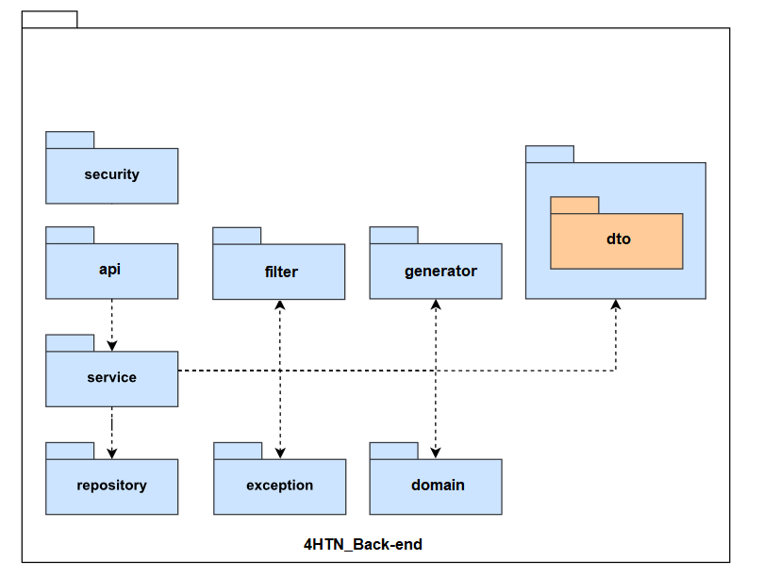

Figure 1.3.2. Backend Package Diagram

|  |  |  |
| --- | --- | --- |
| **No** | **Package** | **Description** |
| 1 | security | Contains classes used for configuration |
| 2 | api | Contains classes which handle incoming requests |
| 3 | service | Contains classes which are used to perform business logic. These classes communicate with data tier, process data then return to controller classes |
| 4 | repository | Contains interfaces which communicate with the database and return them to service classes |
| 5 | filter | Used for authentication and authorization |
| 6 | dto | Contains objects used to transfer data between controller and service |
| 7 | exception | Contains custom exceptions and exceptions handler |
| 8 | domain | Contains classes represent real entities which can be persisted in database and some additional helper classes |
| 9 | generator | Contains objects used to handling combinatorial division algorithm |

Table 1.3.2. Backend package details

## 2. Database Design

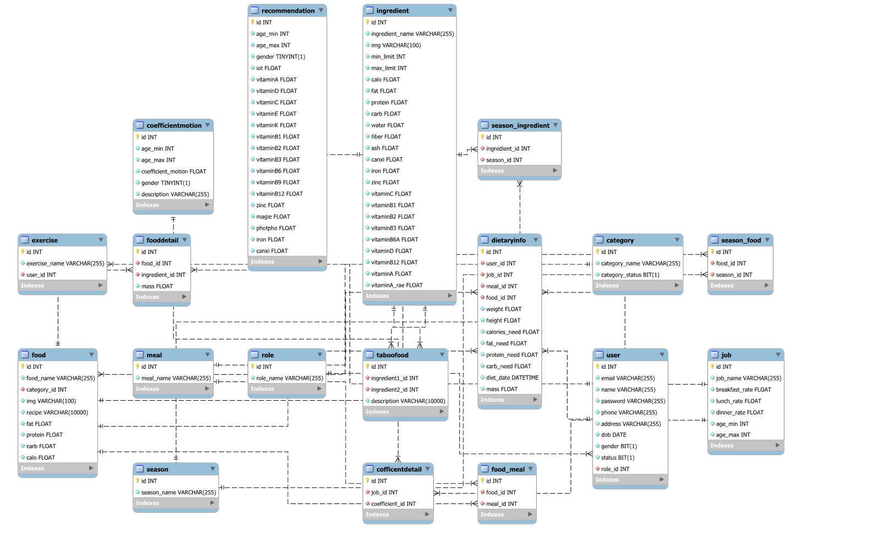

Figure 2. 4HTN Database design

### 2.1. Table “user”

|  |  |  |  |  |  |  |  |
| --- | --- | --- | --- | --- | --- | --- | --- |
| **#** | **Field name** | **Type** | **Size** | **Unique** | **Not Null** | **PK/FK** | **Notes** |
| 1 | id | int |  | x | x | PK |  |
| 2 | email | varchar | 255 |  | x |  |  |
| 3 | name | varchar | 255 |  | x |  |  |
| 4 | password | varchar | 255 |  | x |  |  |
| 5 | phone | varchar | 255 |  | x |  |  |
| 6 | address | date |  |  | x |  |  |
| 7 | gender | bit | 1 |  | x |  |  |
| 8 | status | status | 1 |  | x |  |  |
| 9 | role_id | int |  |  | x |  |  |

Table 2.1. Table”user”

### 2.2. Table “dietaryinfo”

|  |  |  |  |  |  |  |  |
| --- | --- | --- | --- | --- | --- | --- | --- |
| **#** | **Field name** | **Type** | **Size** | **Unique** | **Not Null** | **PK/FK** | **Notes** |
| 1 | id | int |  | x | x | PK |  |
| 2 | user_id | int |  |  | x | FK |  |
| 3 | job_id | int |  |  | x | FK |  |
| 4 | meal_id | int |  |  | x | FK |  |
| 5 | food_id | int |  |  | x | FK |  |
| 6 | weight | float |  |  | x |  |  |
| 7 | height | float |  |  | x |  |  |
| 8 | calories_need | float |  |  | x |  |  |
| 9 | fat_need | float |  |  | x |  |  |
| 10 | protein_need | float |  |  | x |  |  |
| 11 | carb_need | float |  |  | x |  |  |
| 12 | diet_date | datetime |  |  | x |  |  |
| 13 | mass | float |  |  | x |  |  |

Table 2.2. Table”dietaryinfo”

### 2.3. Table “Job”

|  |  |  |  |  |  |  |  |
| --- | --- | --- | --- | --- | --- | --- | --- |
| **#** | **Field name** | **Type** | **Size** | **Unique** | **Not Null** | **PK/FK** | **Notes** |
| 1 | id | int |  | x | x | PK |  |
| 2 | job_name | varchar | 255 |  | x |  |  |
| 3 | breakfast_rate | float |  |  | x |  |  |
| 4 | lunch_rate | float |  |  | x |  |  |
| 5 | dinner_rate | float |  |  | x |  |  |
| 6 | age_min | int |  |  | x |  |  |
| 7 | age_max | int |  |  | x |  |  |

Table 2.3. Table_Job

### 2.4. Table “Food”

|  |  |  |  |  |  |  |  |
| --- | --- | --- | --- | --- | --- | --- | --- |
| **#** | **Field name** | **Type** | **Size** | **Unique** | **Not Null** | **PK/FK** | **Notes** |
| 1 | id | int |  | x | x | PK |  |
| 2 | food_name | varchar | 255 |  | x |  |  |
| 3 | img | varchar | 100 |  | x |  |  |
| 4 | category_id | int |  |  | x | FK |  |
| 5 | recipe | varchar | 10000 |  | x |  |  |
| 6 | fat | float |  |  | x |  |  |
| 7 | protein | float |  |  | x |  |  |
| 8 | carb | float |  |  | x |  |  |
| 9 | calo | float |  |  | x |  |  |

Table 2.4. Table_Food

### 2.5. Table “Category”

|  |  |  |  |  |  |  |  |
| --- | --- | --- | --- | --- | --- | --- | --- |
| **#** | **Field name** | **Type** | **Size** | **Unique** | **Not Null** | **PK/FK** | **Notes** |
| 1 | id | int |  | x | x | PK |  |
| 2 | category_name | varchar | 255 |  | x |  |  |
| 3 | category_status | bit | 1 |  | x |  |  |

Table 2.5. Table Category

### 2.6. Table “Season”

|  |  |  |  |  |  |  |  |
| --- | --- | --- | --- | --- | --- | --- | --- |
| **#** | **Field name** | **Type** | **Size** | **Unique** | **Not Null** | **PK/FK** | **Notes** |
| 1 | id | int |  | x | x | PK |  |
| 2 | season_name | varchar | 255 |  | x |  |  |

Table 2.6. Table Season

### 2.7. Table “CoefficentMotion”

|  |  |  |  |  |  |  |  |
| --- | --- | --- | --- | --- | --- | --- | --- |
| **#** | **Field name** | **Type** | **Size** | **Unique** | **Not Null** | **PK/FK** | **Notes** |
| 1 | id | int |  | x | x | PK |  |
| 2 | age_min | int |  |  | x |  |  |
| 3 | age_max | int |  |  | x |  |  |
| 4 | coefficient_motion | float |  |  | x |  |  |
| 5 | gender | tinyint | 1 |  | x |  |  |
| 6 | description | varchar | 255 |  | x |  |  |

Table 2.7. Table “CoefficentMotion”

### 2.8. Table “Recommendation”

|  |  |  |  |  |  |  |  |
| --- | --- | --- | --- | --- | --- | --- | --- |
| **#** | **Field name** | **Type** | **Size** | **Unique** | **Not Null** | **PK/FK** | **Notes** |
| 1 | id |  |  | x | x | PK |  |
| 2 | min_age | int |  |  | x |  |  |
| 3 | max_age | int |  |  | x |  |  |
| 4 | gender | tinyint |  |  | x |  |  |
| 5 | iot | float |  |  | x |  |  |
| 6 | maggie | float |  |  | x |  |  |
| 7 | photpho | float |  |  | x |  |  |
| 8 | vitaminB9 | float |  |  | x |  |  |
| 9 | vitaminE | float |  |  | x |  |  |
| 10 | fiber | float |  |  | x |  |  |
| 11 | ash | float |  |  | x |  |  |
| 12 | canxi | float |  |  | x |  |  |
| 13 | iron | float |  |  | x |  |  |
| 14 | zinc | float |  |  | x |  |  |
| 15 | vitaminC | float |  |  | x |  |  |
| 16 | vitaminB1 | float |  |  | x |  |  |
| 17 | vitaminB2 | float |  |  | x |  |  |
| 18 | vitaminB3 | float |  |  | x |  |  |
| 19 | vitaminB6A | float |  |  | x |  |  |
| 20 | vitaminB12 | float |  |  | x |  |  |
| 21 | vitaminD | float |  |  | x |  |  |
| 22 | vitaminA | float |  |  | x |  |  |

Table 2.8. Table”Remommendation”

### 2.9. Table “Ingredient”

|  |  |  |  |  |  |  |  |
| --- | --- | --- | --- | --- | --- | --- | --- |
| **#** | **Field name** | **Type** | **Size** | **Unique** | **Not Null** | **PK/FK** | **Notes** |
| 1 | id | bigserial |  | x | x | PK |  |
| 2 | ingredient_name | varchar | 255 |  | x |  |  |
| 3 | img | varchar | 100 |  | x |  |  |
| 4 | min_limit | int |  |  | x |  |  |
| 5 | max_limit | int |  |  | x |  |  |
| 6 | calo | float |  |  | x |  |  |
| 7 | carb | float |  |  | x |  |  |
| 8 | protein | float |  |  | x |  |  |
| 9 | fat | float |  |  | x |  |  |
| 10 | water | float |  |  | x |  |  |
| 11 | fiber | float |  |  | x |  |  |
| 12 | ash | float |  |  | x |  |  |
| 13 | canxi | float |  |  | x |  |  |
| 14 | iron | float |  |  | x |  |  |
| 15 | zinc | float |  |  | x |  |  |
| 16 | vitaminC | float |  |  |  |  |  |
| 17 | vitaminB1 | float |  |  | x | FK |  |
| 18 | vitaminB2 | float |  |  | x | FK |  |
| 19 | vitaminB3 | float |  |  | x |  |  |
| 20 | vitaminB6A | float |  |  | x |  |  |
| 21 | vitaminB12 | float |  |  | x |  |  |
| 22 | vitaminD | float |  |  |  |  |  |
| 23 | vitaminA | float |  |  |  |  |  |
| 24 | vitaminArae | float |  |  |  |  |  |

Table 2.9. Table “Ingredient”

### 2.10. Table “Season_Ingredient”

|  |  |  |  |  |  |  |  |
| --- | --- | --- | --- | --- | --- | --- | --- |
| **#** | **Field name** | **Type** | **Size** | **Unique** | **Not Null** | **PK/FK** | **Notes** |
| 1 | id |  |  | x | x | PK |  |
| 2 | season_id | int |  |  | x |  |  |
| 3 | ingredient_id | int |  |  | x |  |  |

Table 2.10. Season_Ingredient

### 2.11. Table “FoodDetail”

|  |  |  |  |  |  |  |  |
| --- | --- | --- | --- | --- | --- | --- | --- |
| **#** | **Field name** | **Type** | **Size** | **Unique** | **Not Null** | **PK/FK** | **Notes** |
| 1 | id | int |  | x | x | PK |  |
| 2 | food_id | int |  |  | x | FK |  |
| 3 | ingredient_id | int |  |  | x | FK |  |
| 4 | mass | int |  |  | x |  |  |

Table 2.11. Table “Food_Detail”

### 2.12. Table “Meal”

|  |  |  |  |  |  |  |  |
| --- | --- | --- | --- | --- | --- | --- | --- |
| **#** | **Field name** | **Type** | **Size** | **Unique** | **Not Null** | **PK/FK** | **Notes** |
| 1 | meal_id | int |  |  | x | PK |  |
| 2 | meal_name | varchar | 255 |  | x |  |  |

Table 2.12. Table “Meal”

### 2.13. Table “Food_meal”

|  |  |  |  |  |  |  |  |
| --- | --- | --- | --- | --- | --- | --- | --- |
| **#** | **Field name** | **Type** | **Size** | **Unique** | **Not Null** | **PK/FK** | **Notes** |
| 1 | id | int |  | x | x | PK |  |
| 2 | food_id | int |  |  | x | FK |  |
| 3 | meal_id | int |  |  | x | FK |  |

Table 2.13. Table “Food_Meal”

### 2.14. Table “Taboo_Food”

|  |  |  |  |  |  |  |  |
| --- | --- | --- | --- | --- | --- | --- | --- |
| **#** | **Field name** | **Type** | **Size** | **Unique** | **Not Null** | **PK/FK** | **Notes** |
| 1 | id | int |  | x | x | PK |  |
| 2 | Ingredient1_id | int |  |  | x |  |  |
| 3 | Ingredient2_id | int |  |  | x |  |  |
| 4 | description | varchar | 255 |  | x |  |  |

Table 2.14. Table”Tabbo_Food”

### 2.15. Table “Role”

|  |  |  |  |  |  |  |  |
| --- | --- | --- | --- | --- | --- | --- | --- |
| **#** | **Field name** | **Type** | **Size** | **Unique** | **Not Null** | **PK/FK** | **Notes** |
| 1 | id | int | 8 | x | x | PK |  |
| 2 | role_name | varchar | 255 |  | x |  |  |

Table 2.15. tbl_province

### 2.16. Table “Season_Food”

|  |  |  |  |  |  |  |  |
| --- | --- | --- | --- | --- | --- | --- | --- |
| **#** | **Field name** | **Type** | **Size** | **Unique** | **Not Null** | **PK/FK** | **Notes** |
| 1 | id |  |  | x | x | PK |  |
| 2 | food_id | int |  |  | x | FK |  |
| 3 | Season_id | int |  |  | x | FK |  |

Table 2.16. Season_Food

### 2.17. Table “Exercise”

|  |  |  |  |  |  |  |  |
| --- | --- | --- | --- | --- | --- | --- | --- |
| **#** | **Field name** | **Type** | **Size** | **Unique** | **Not Null** | **PK/FK** | **Notes** |
| 1 | id | int |  | x | x | PK |  |
| 2 | user_id | int |  |  | x | FK |  |
| 3 | exercise_name | varchar | 255 |  | x |  |  |

Table 2.17. Table”Exercise”

## 3. Detail Design

### 3.1. Feature “Login and Register”

#### 3.1.1. Class Diagram

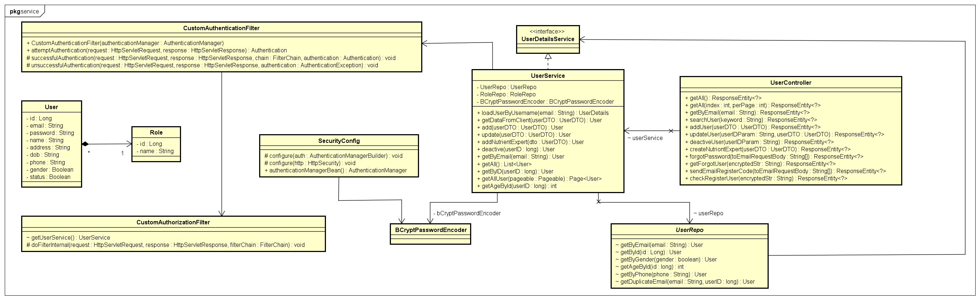

Figure 3.1. “Login and Register” Class Digram

#### 3.1.2. Sequence Diagram(s)

##### 3.1.2.1. Login

Figure 3.1.2.1. “Login” Sequence Diagram

##### 3.1.2.2. Register

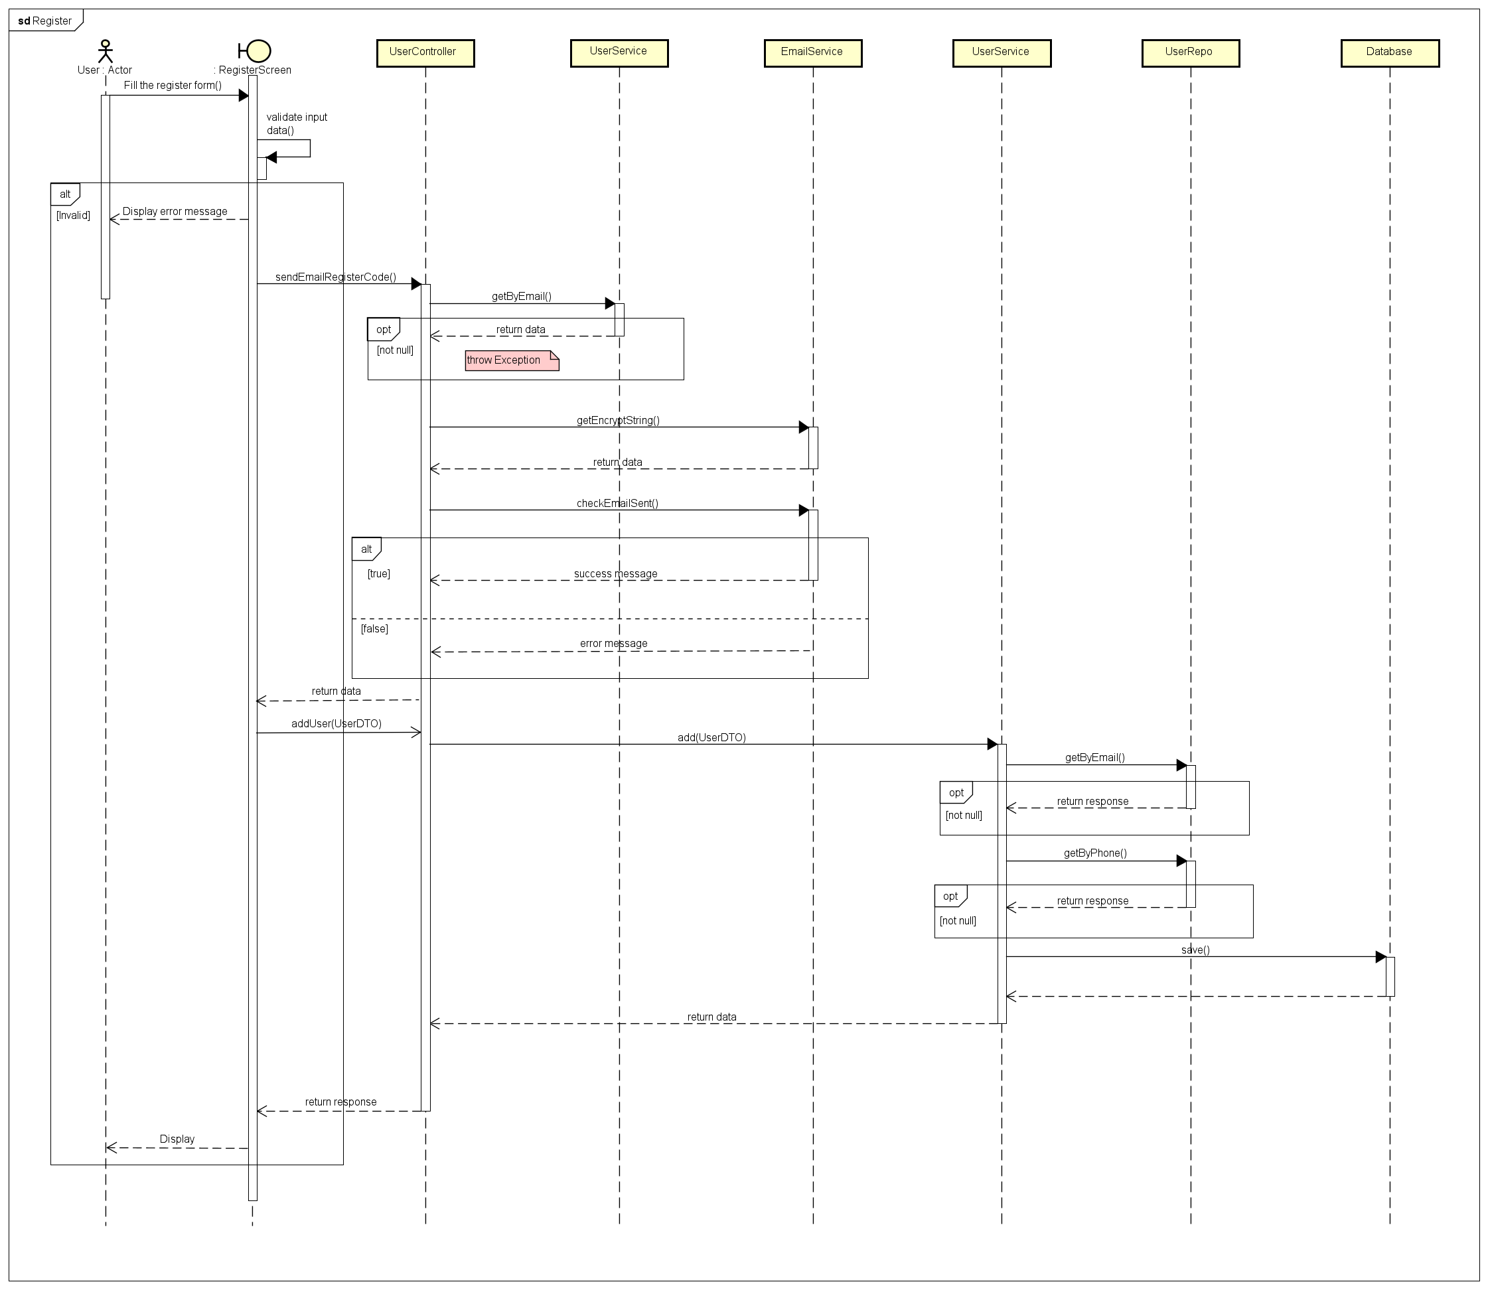

Figure 3.1.2.2. “Register” Sequence Diagram

##### 3.1.2.3. Forgot password

Figure 3.1.2.3. “Forgot password” Sequence Diagram

### 3.2. Feature “Manage personal profile”

#### 3.2.1. Class Diagram

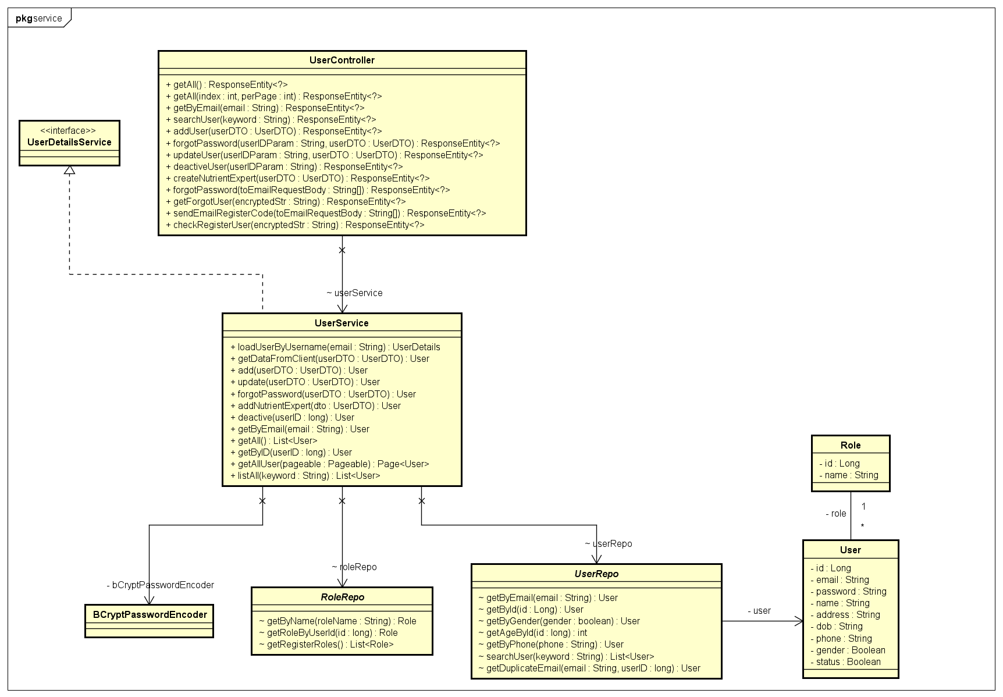

Figure 3.2. “Manage personal profile” Class Diagram

#### 3.2.2. Sequence Diagram(s)

##### 3.2.2.1. View personal profile

Figure 3.2.2.1. “View personal profile” Sequence Diagram

##### 3.2.2.2. Edit personal profile

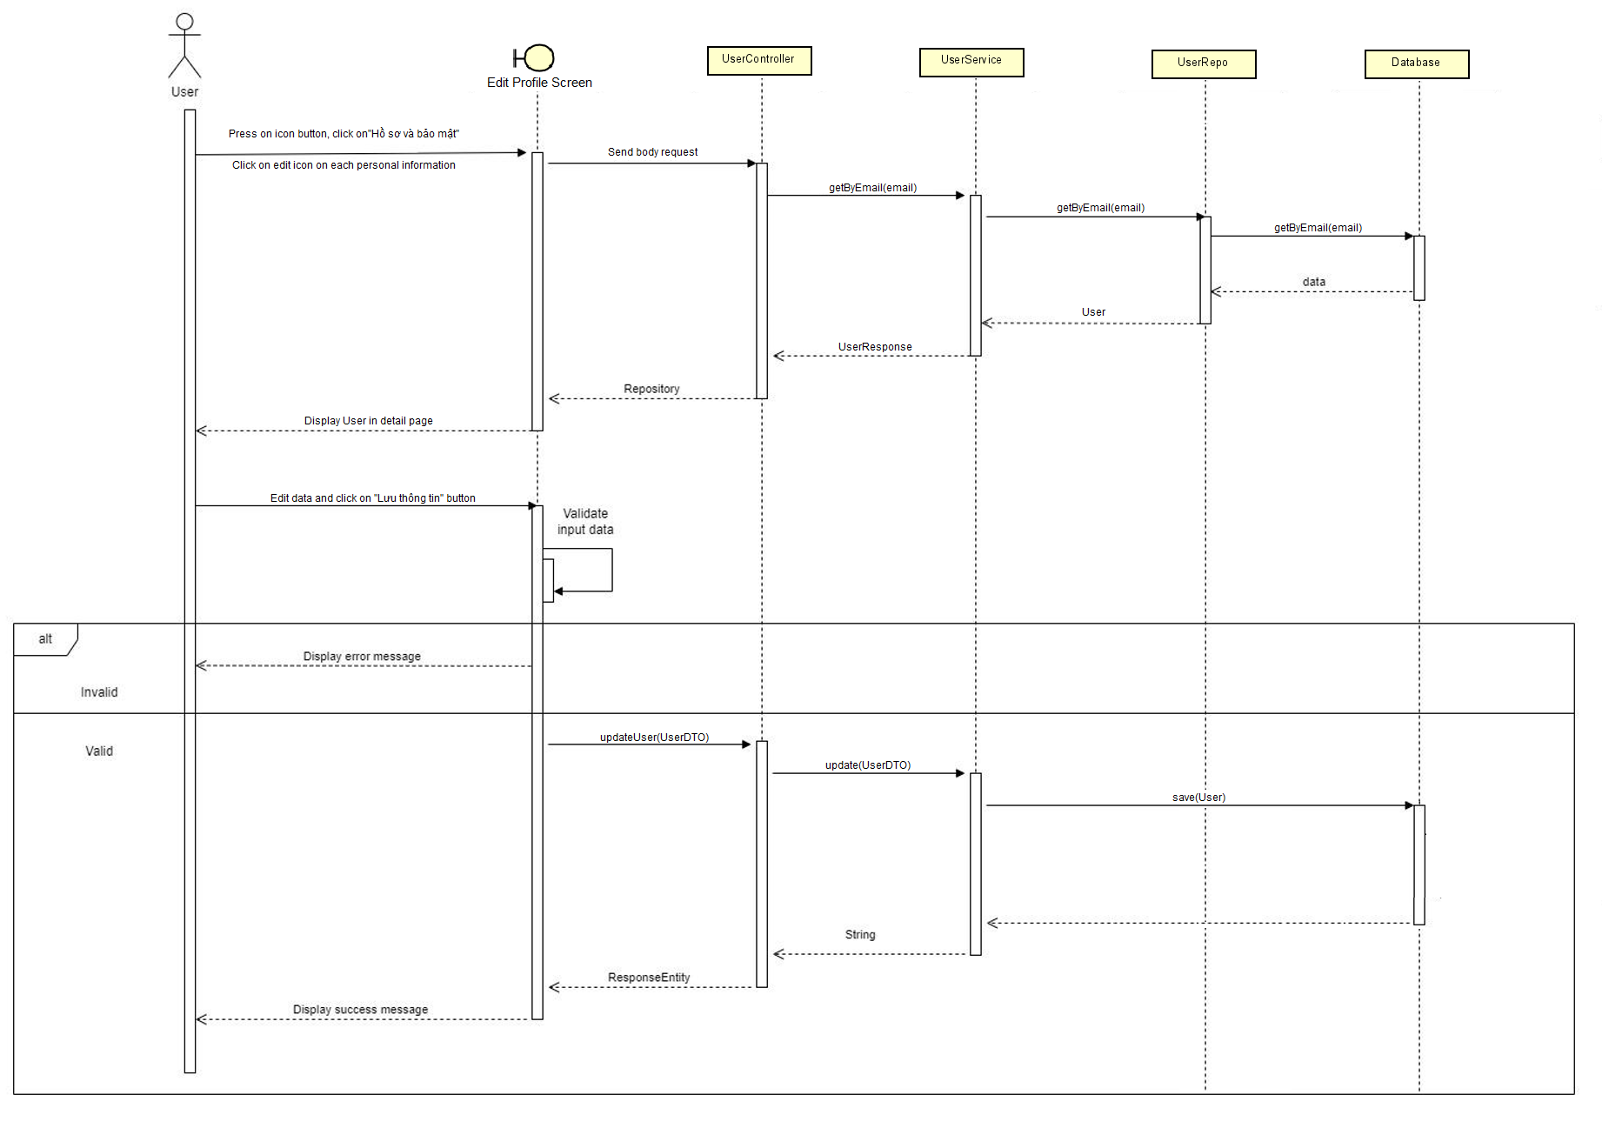

Figure 3.2.2.2. “Edit personal profile” Sequence Diagram

##### 3.2.2.3. Change password

Figure 3.2.2.3. “Change password” Sequence Diagram

##### 3.2.2.4.

Figure 3.2.2.4. “Change password” Sequence Diagram

##### 3.2.2.5. Send email

Figure 3.2.2.5. “Send Email” Sequence Diagram

##### 3.2.2.6. Validate email

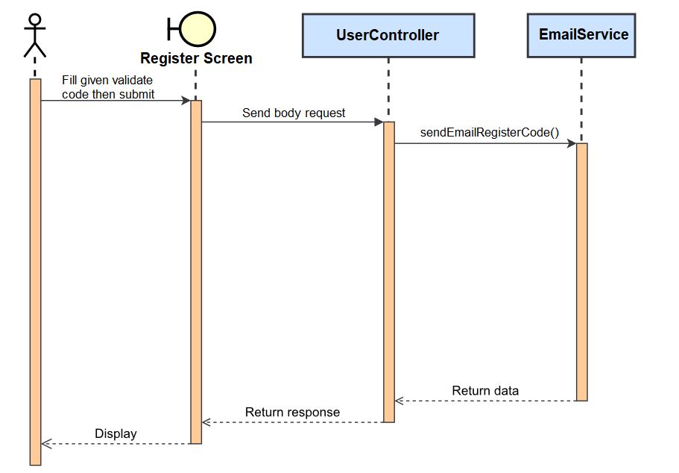

Figure 3.2.2.5. “Validate email” Sequence Diagram

### 

### 3.3. Feature “Manage system accounts”

#### 3.3.1. Class Diagram



Figure 3.3.1. “Manage system accounts” Class Diagram

#### 3.3.2. Sequence Diagram(s)

##### 3.3.2.1. View system account list

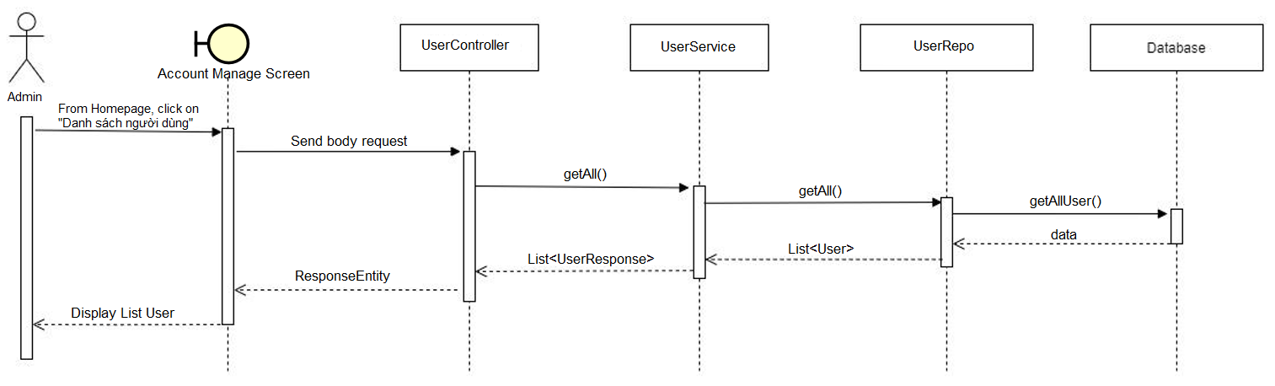

Figure 3.3.2.1. “View system account list” Sequence Diagram

##### 3.3.2.2. View account details

Figure 3.3.2.2. “View account details” Sequence Diagram

### 3.4. Feature “Manage Food”

#### 3.4.1. Class Diagram

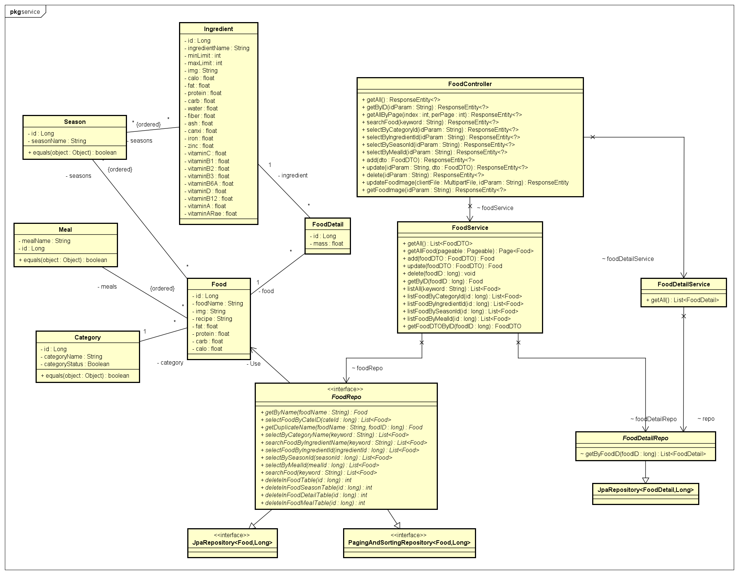

Figure 3.4.1. “Manage Food” Class Diagram

#### 3.4.2. Sequence Diagram(s)

##### 3.4.2.1. Add Food

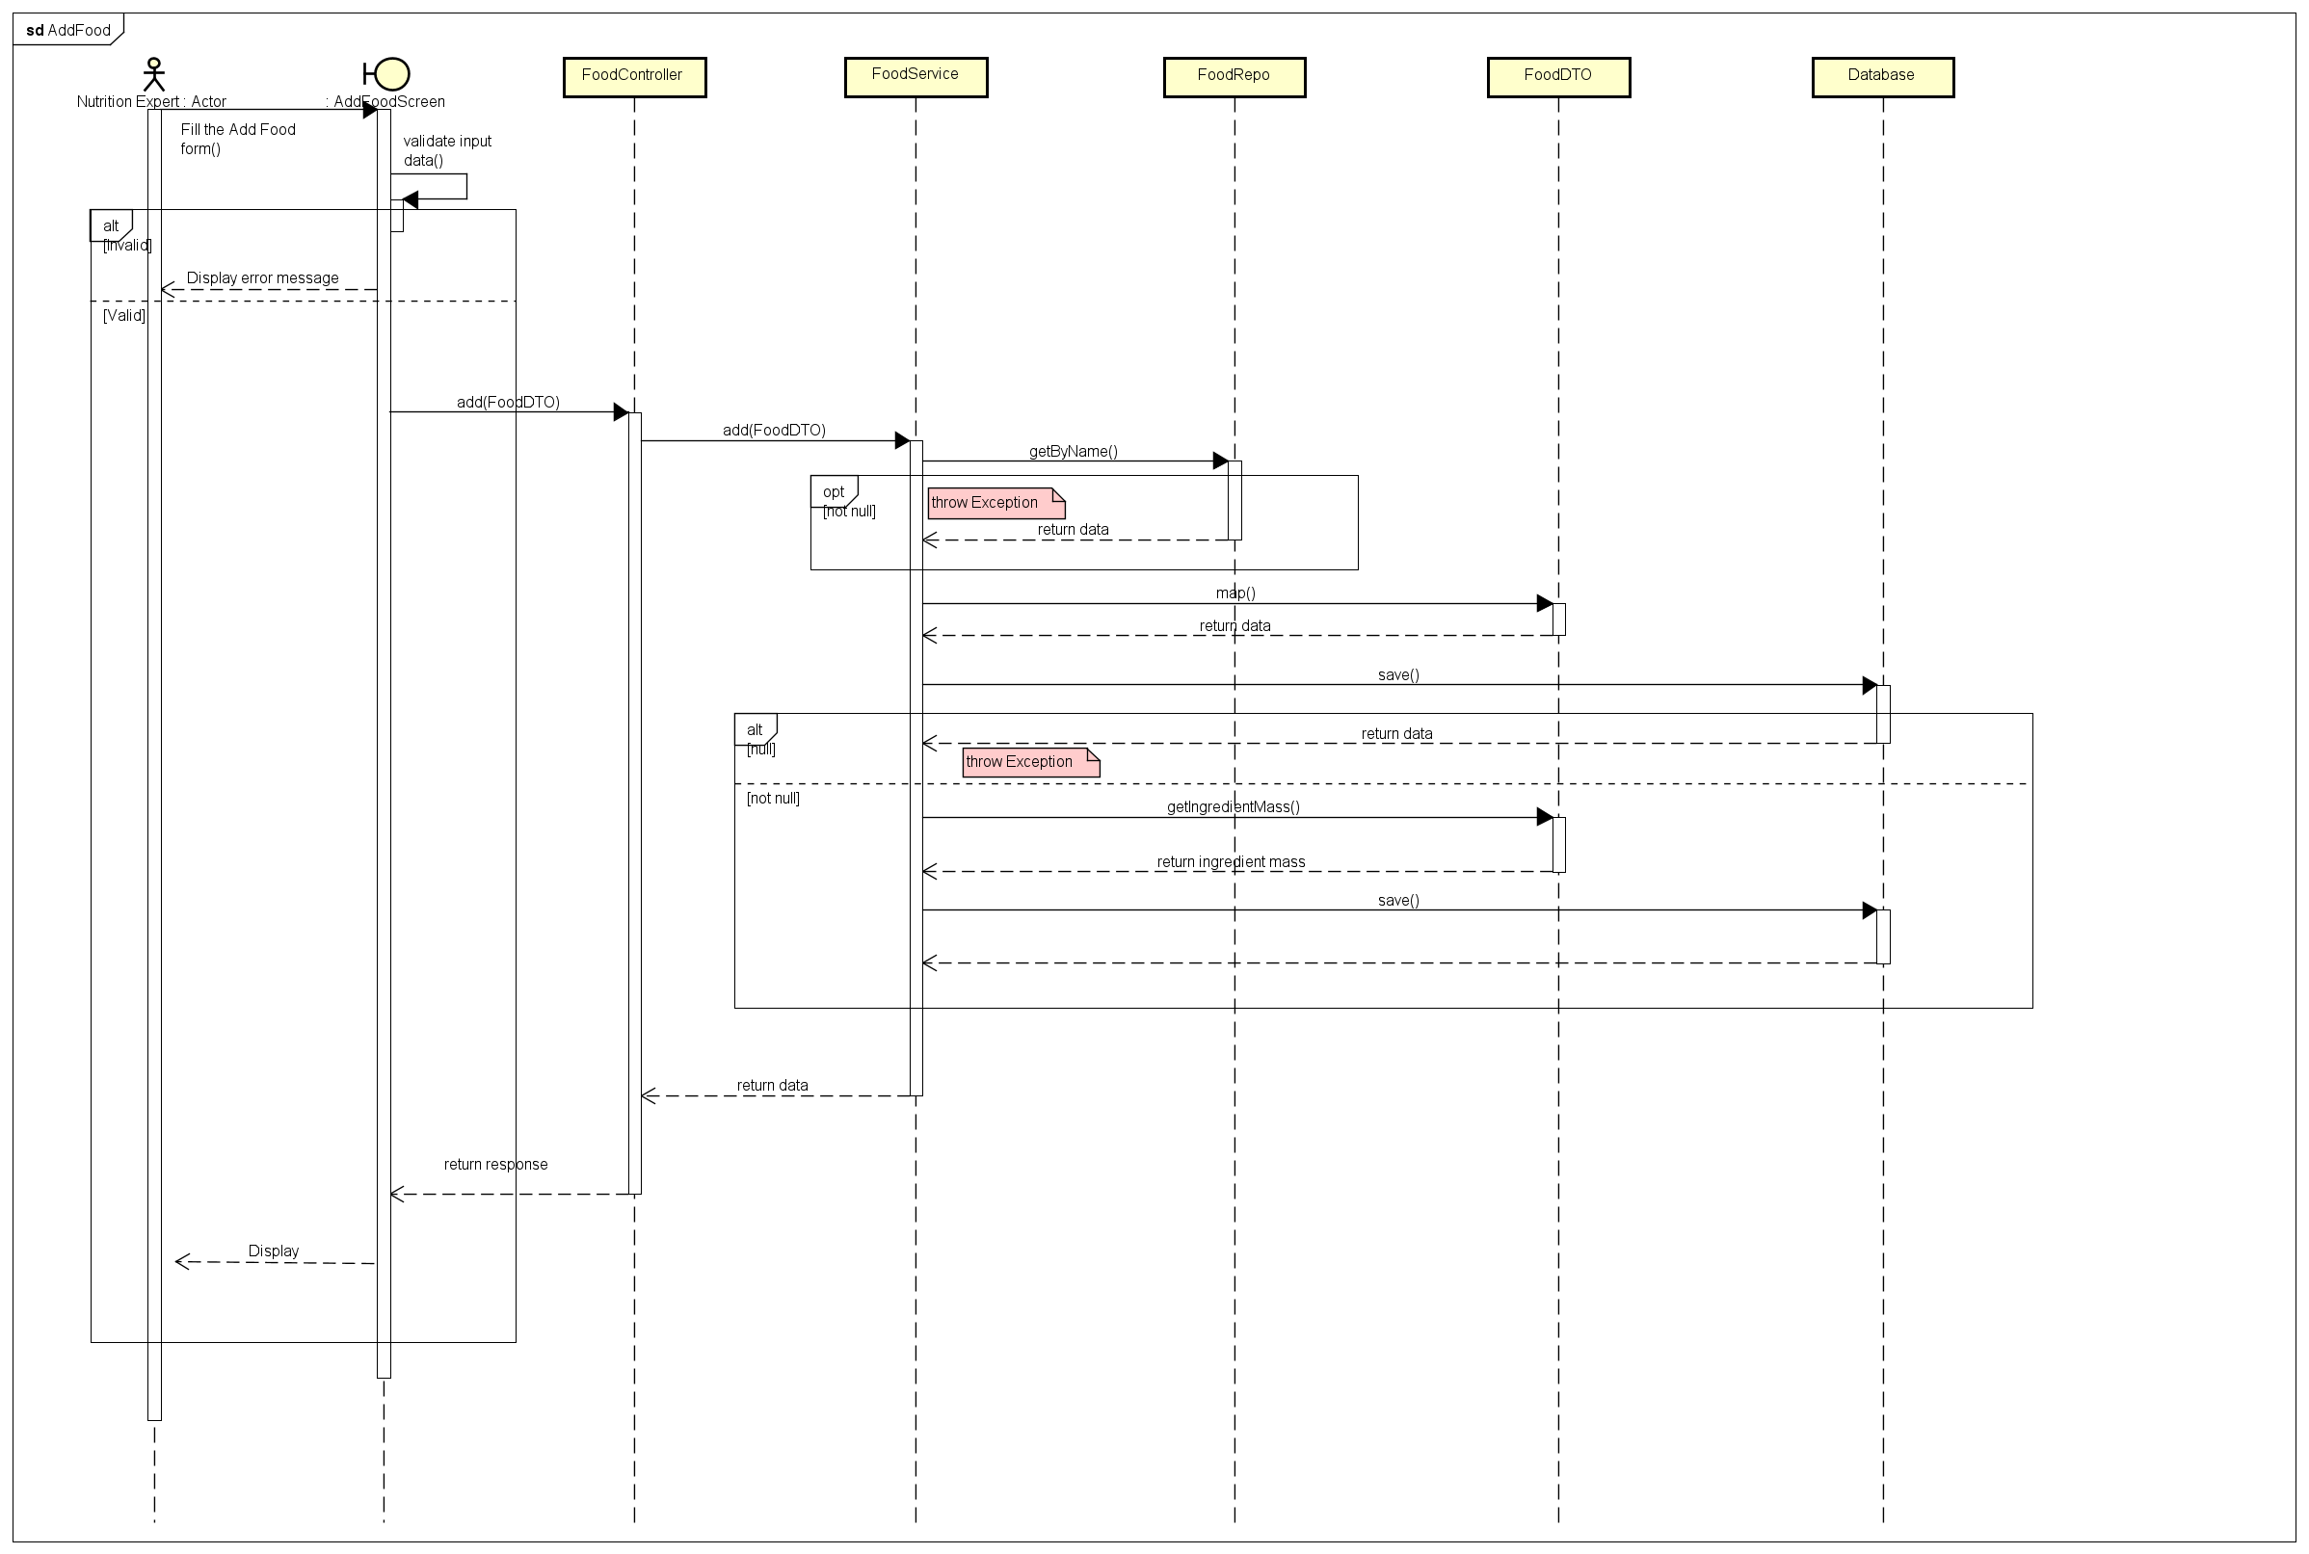

Figure 3.4.2.1. “Add Food” Sequence Diagram

##### 3.4.2.3. Edit Ingredient

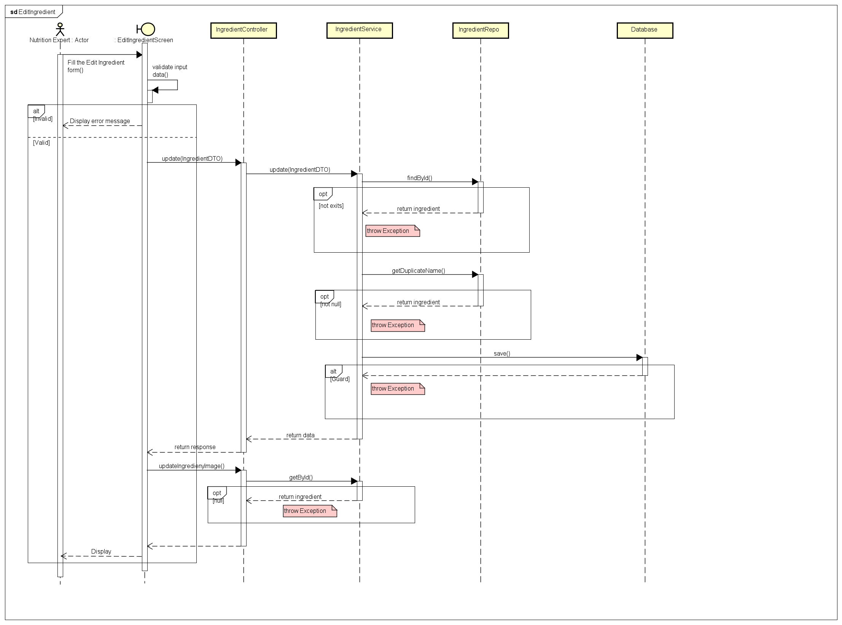

Figure 3.4.2.3. “Edit Ingredient” Sequence Diagram

##### 3.4.2.4. Delete Food

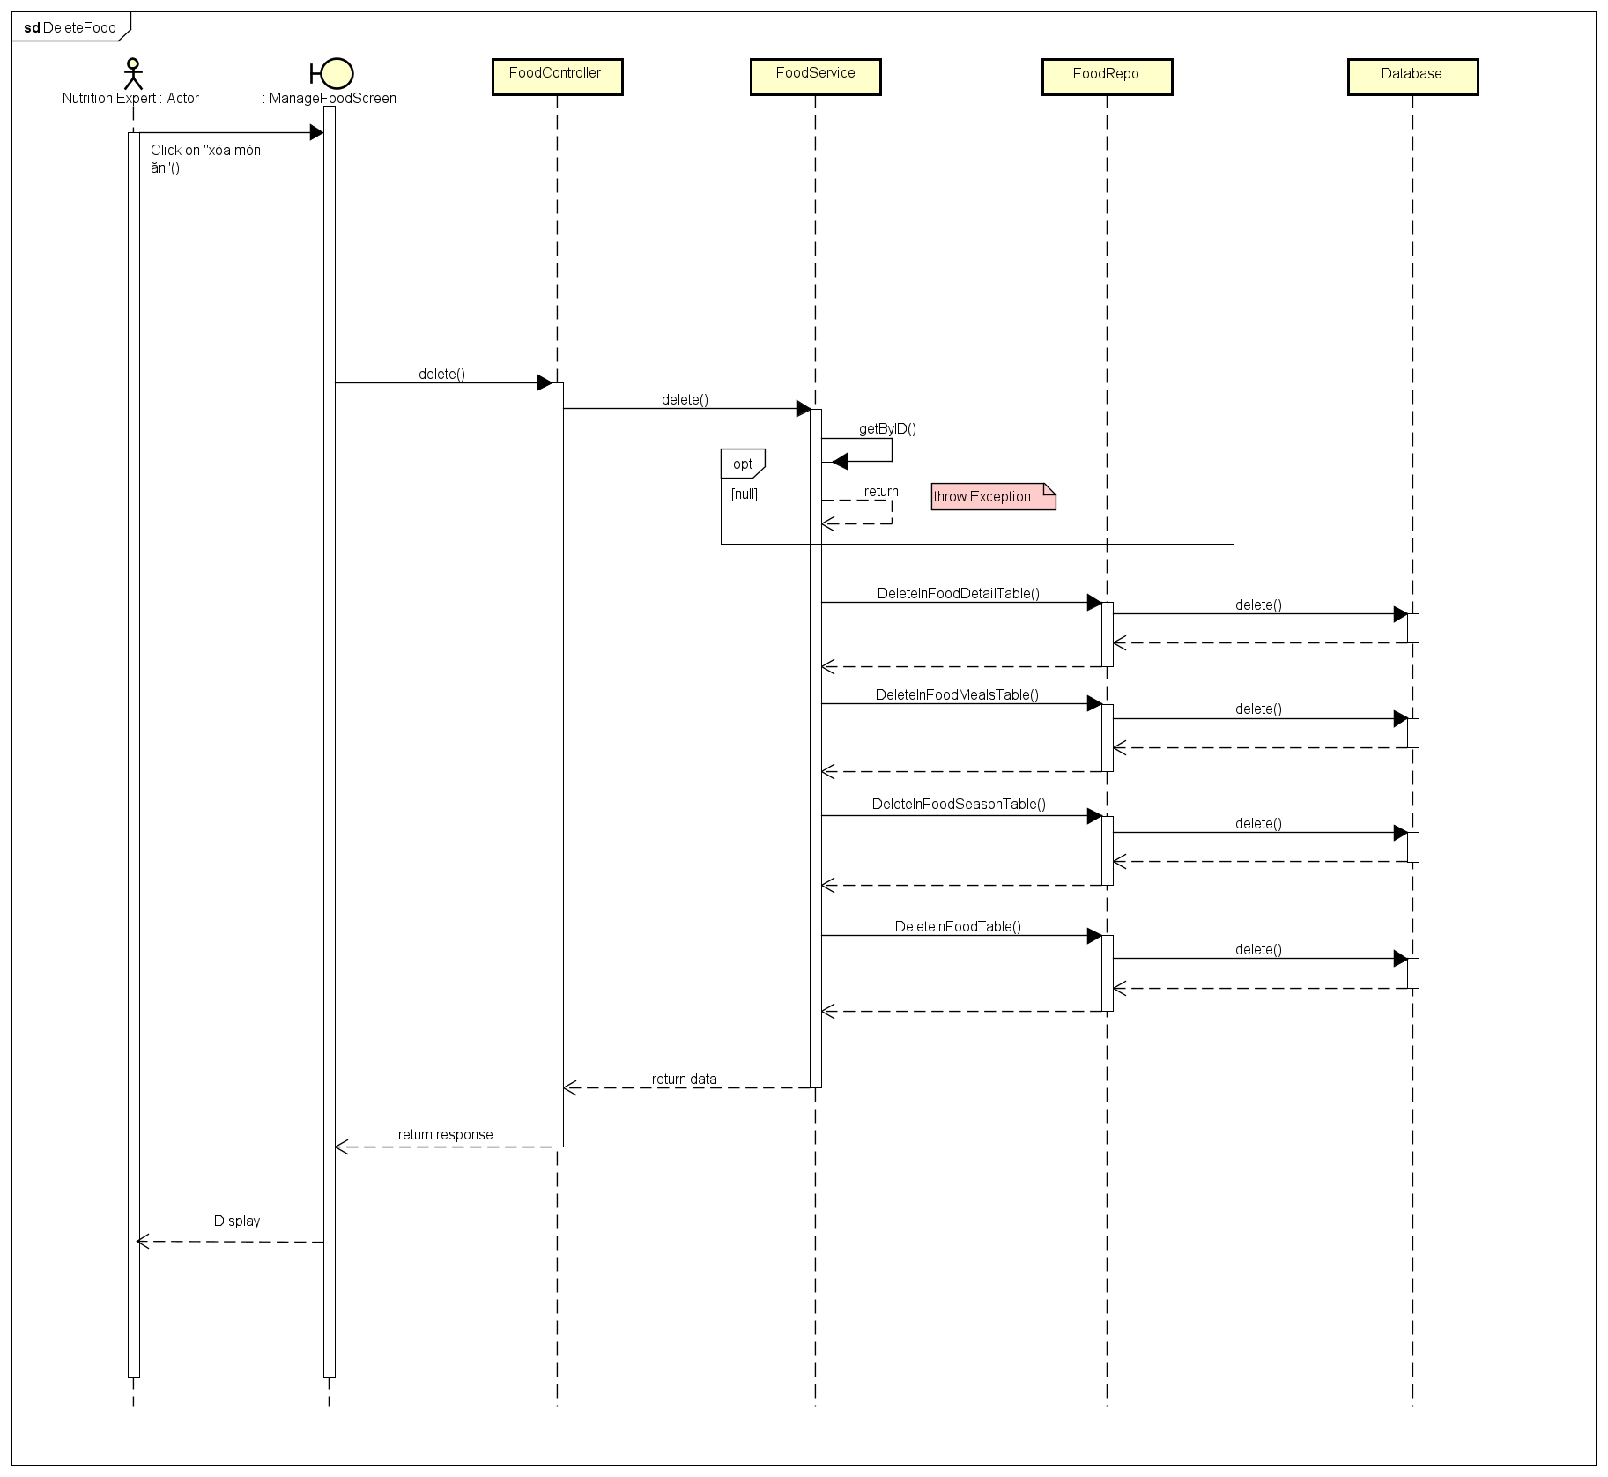

Figure 3.4.2.4. “Delete Food” Sequence Diagram

##### 3.4.2.5. Edit Food

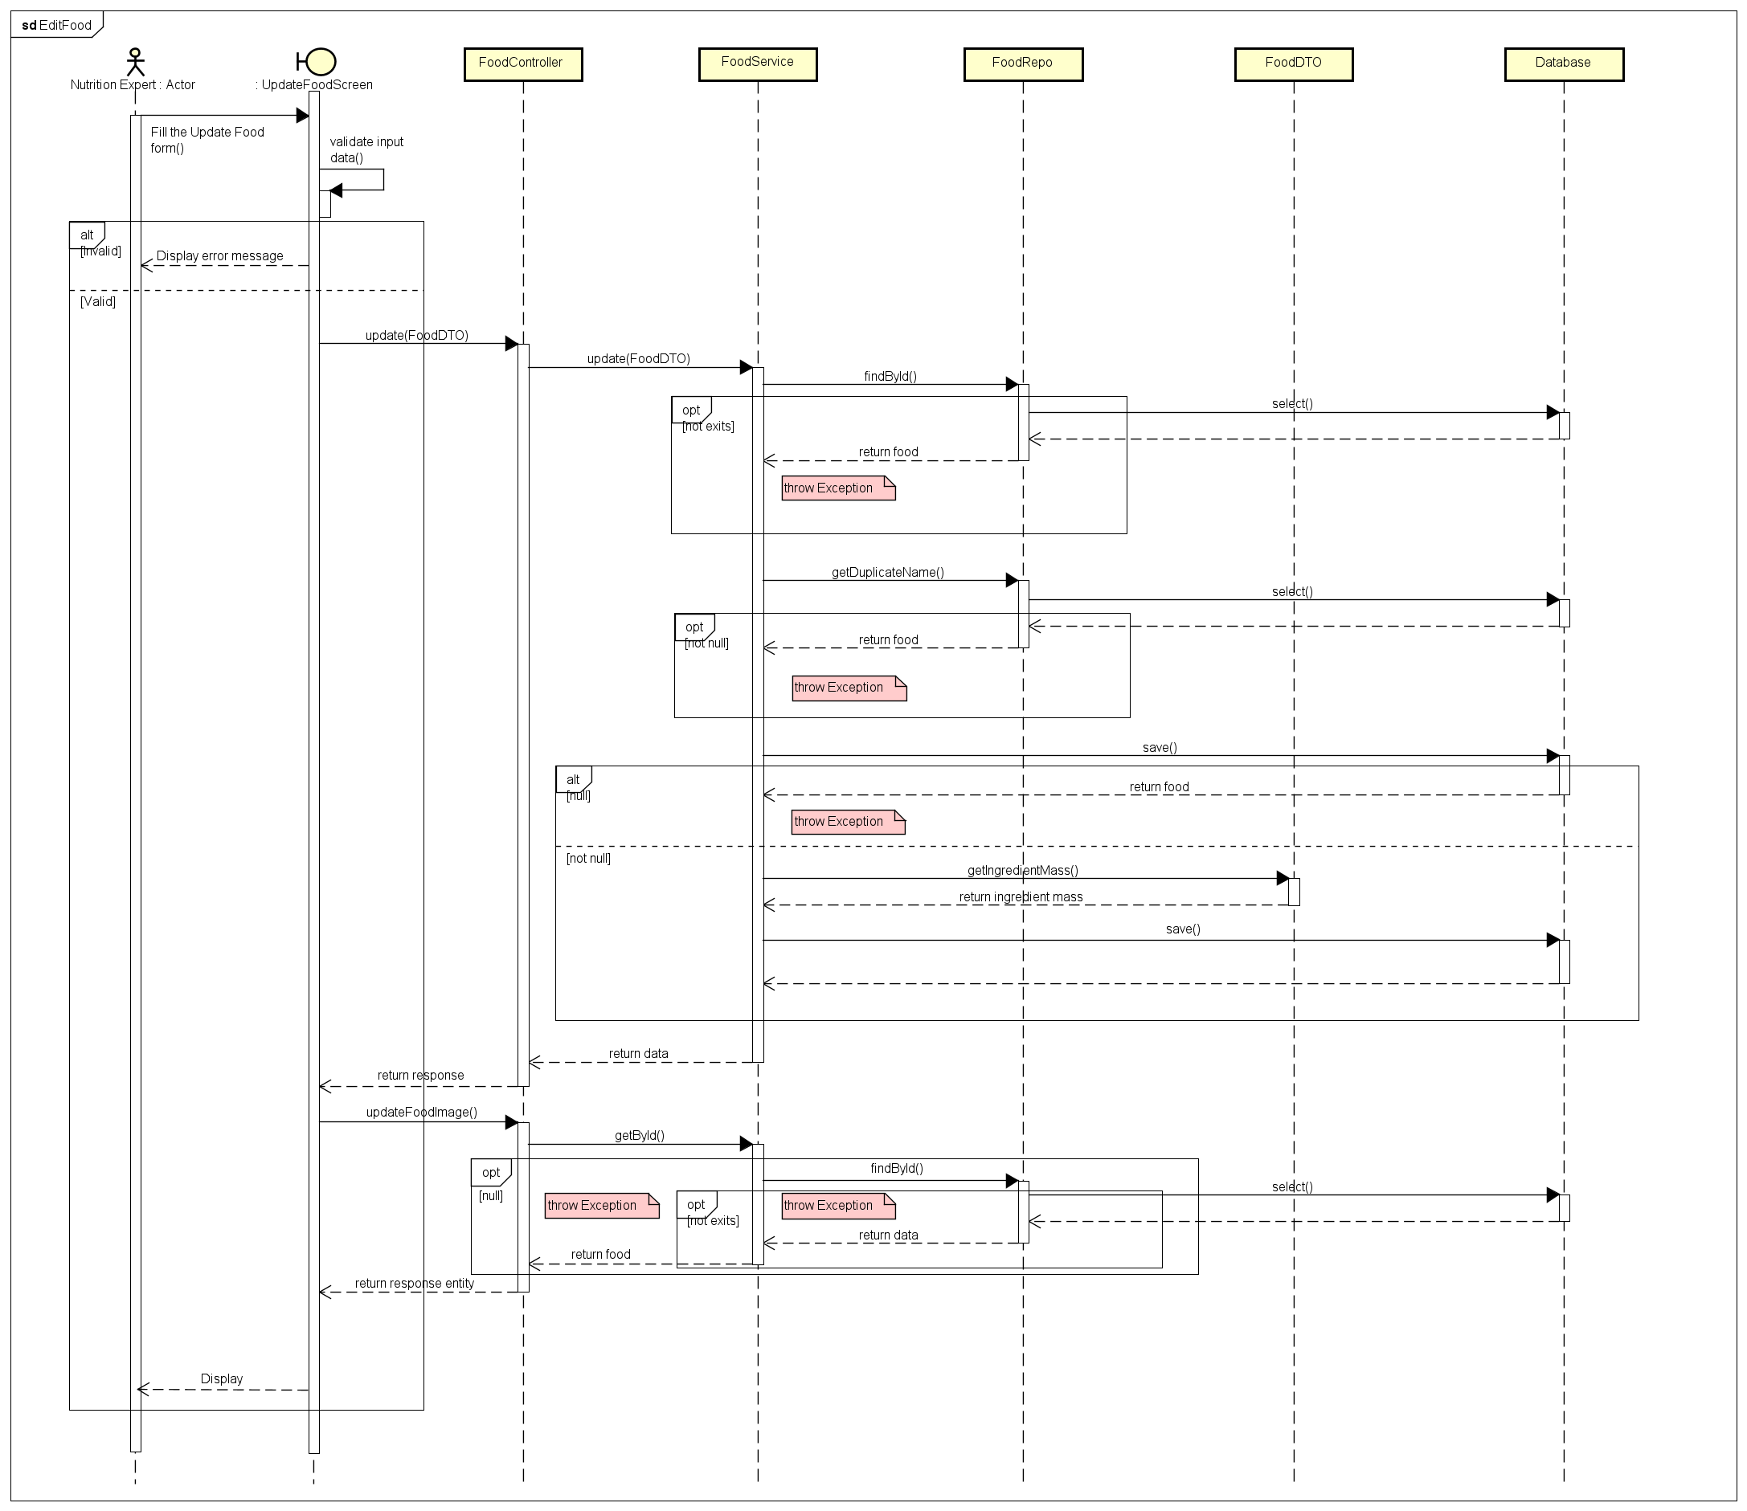

Figure 3.4.2.5. “Edit Food” Sequence Diagram

##### 3.4.2.6. Delete Ingredient

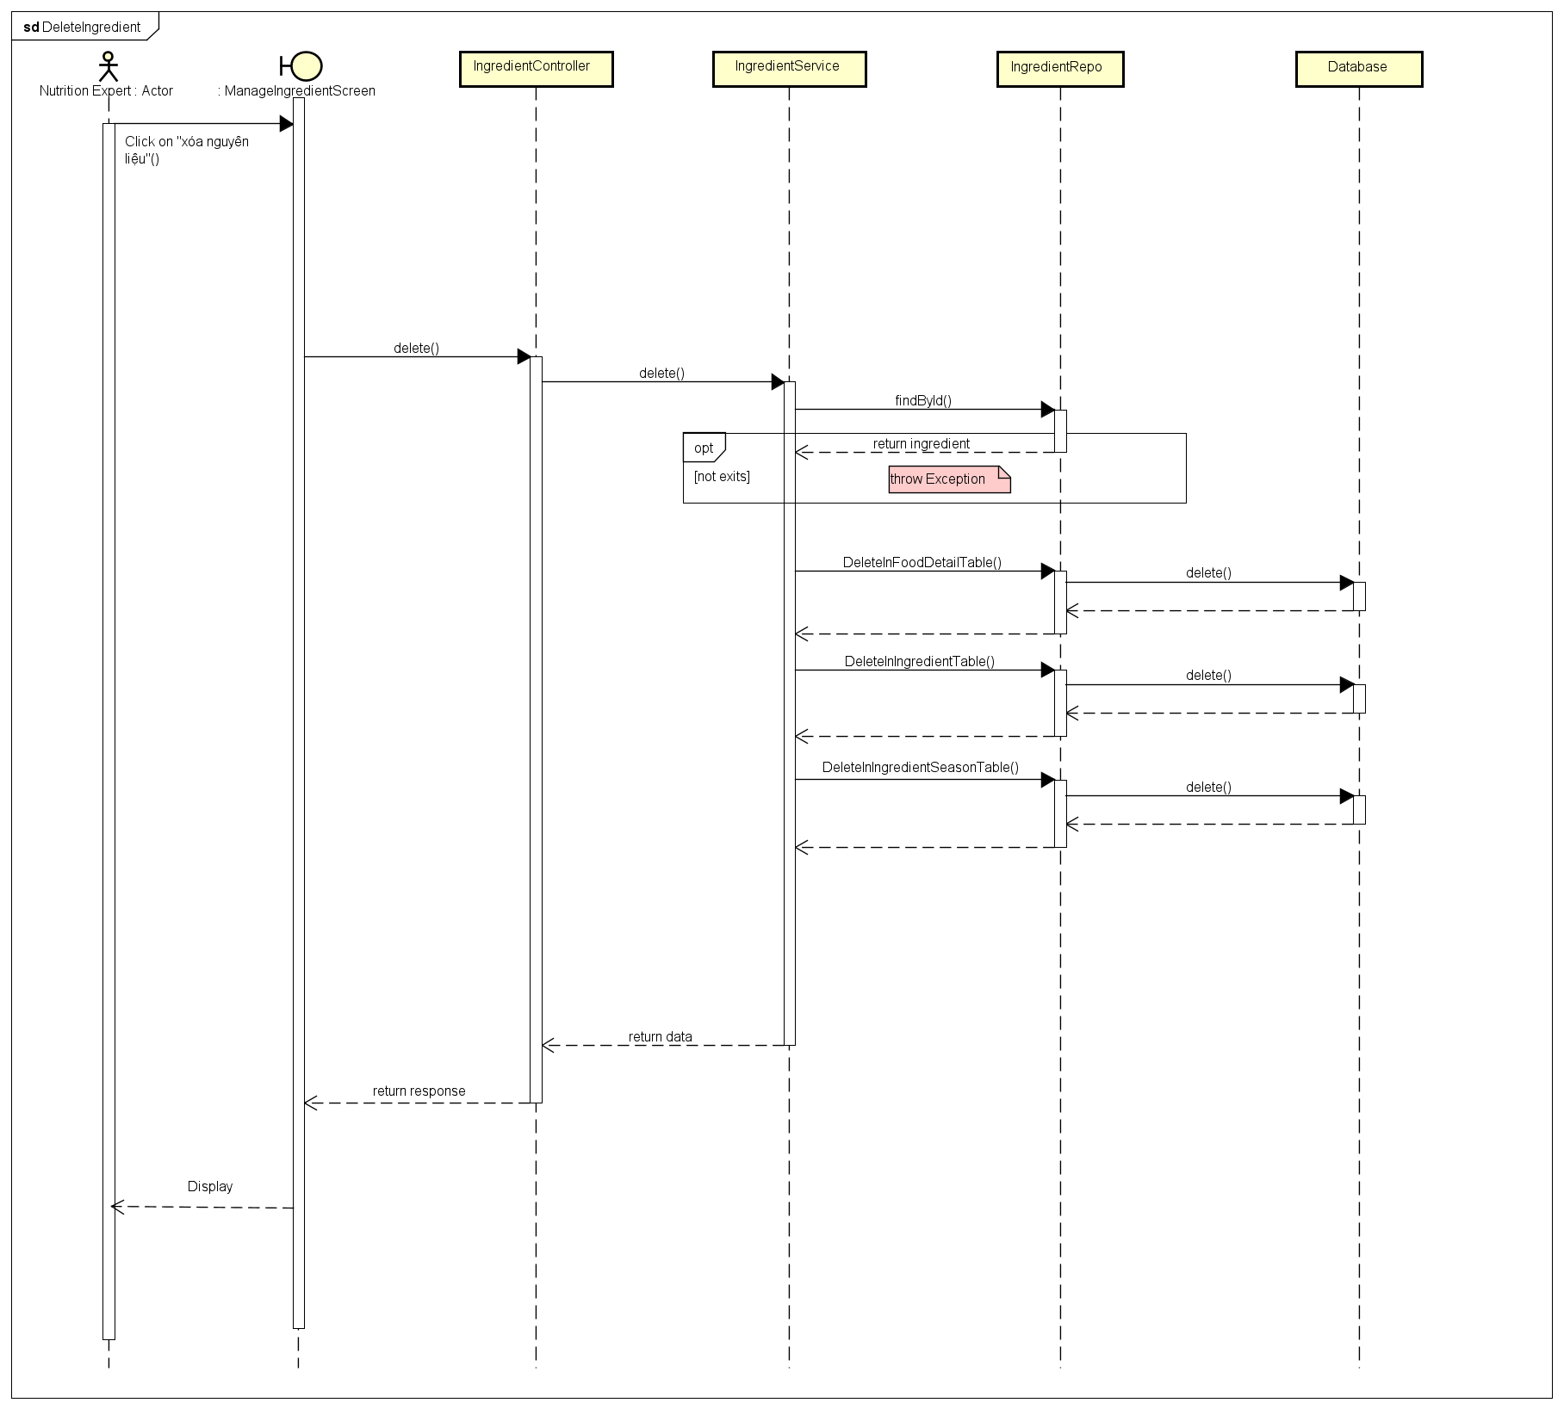

Figure 3.4.2.6. “Delete Ingredient” Sequence Diagram

##### 3.4.2.7. Add Ingredient

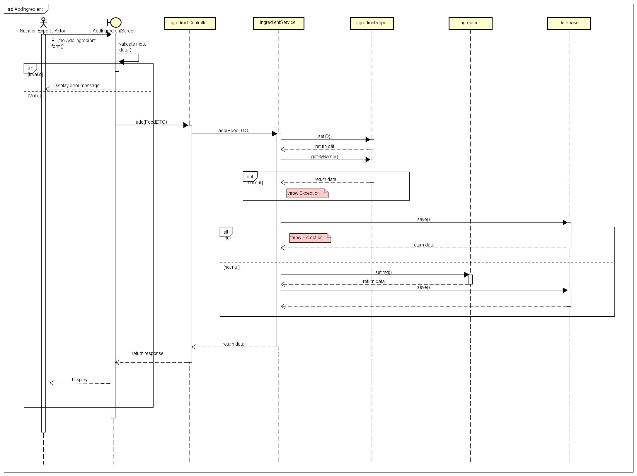

Figure 3.4.2.7. “Add Ingredient” Sequence Diagram

### 3.5. Feature “Search Food and Ingredient”

#### 3.5.1. Class Diagram

Figure 3.5.1. “Manage fishing location’s reviews” Class Diagram

#### 3.5.2. Sequence Diagram(s)

##### 3.5.2.1. Search Food by Name

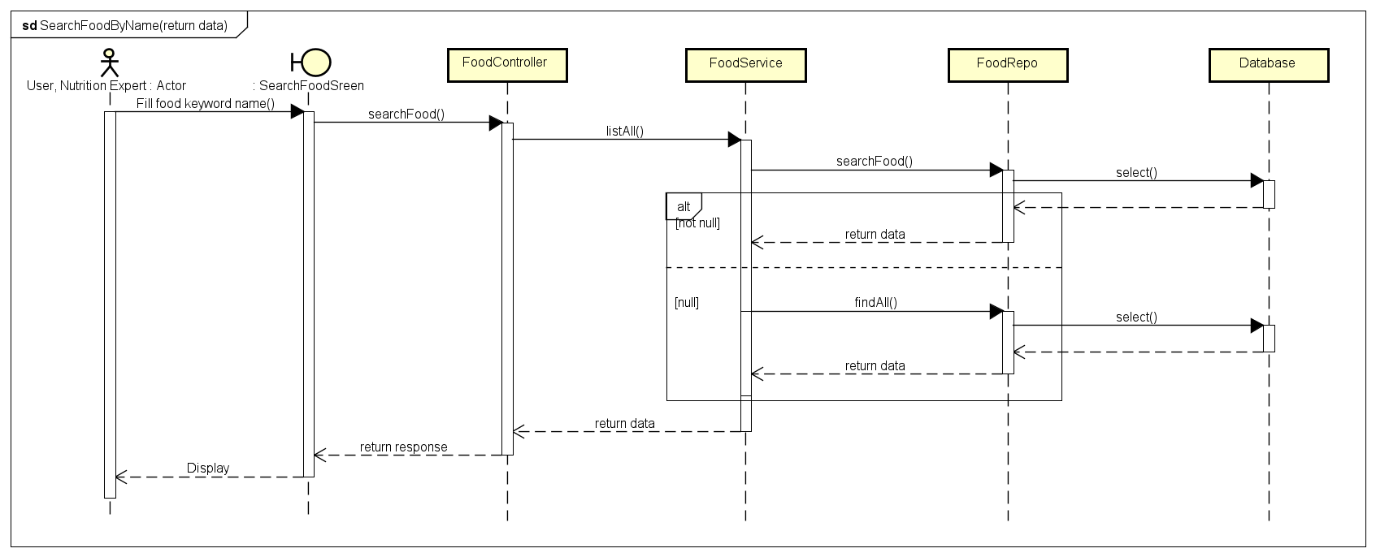

Figure 3.5.2.1. “” Sequence Diagram

##### 3.5.2.2. Search Ingredient by Name

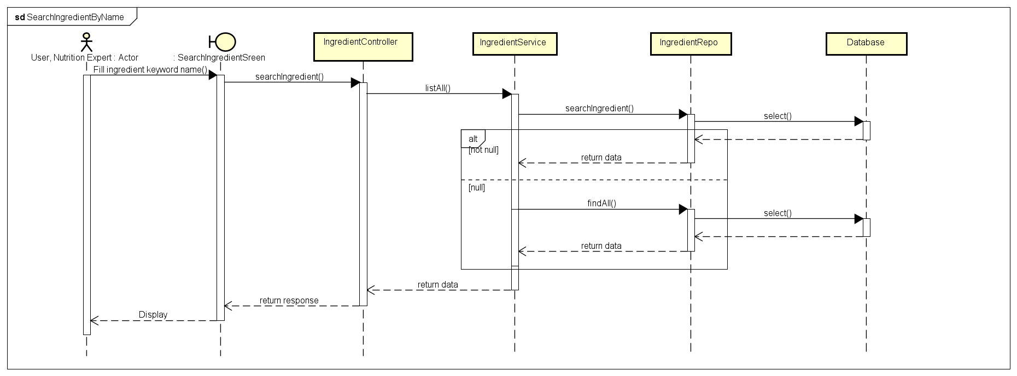

Figure 3.5.2.2. “” Sequence Diagram

##### 3.5.2.3. Filter Food

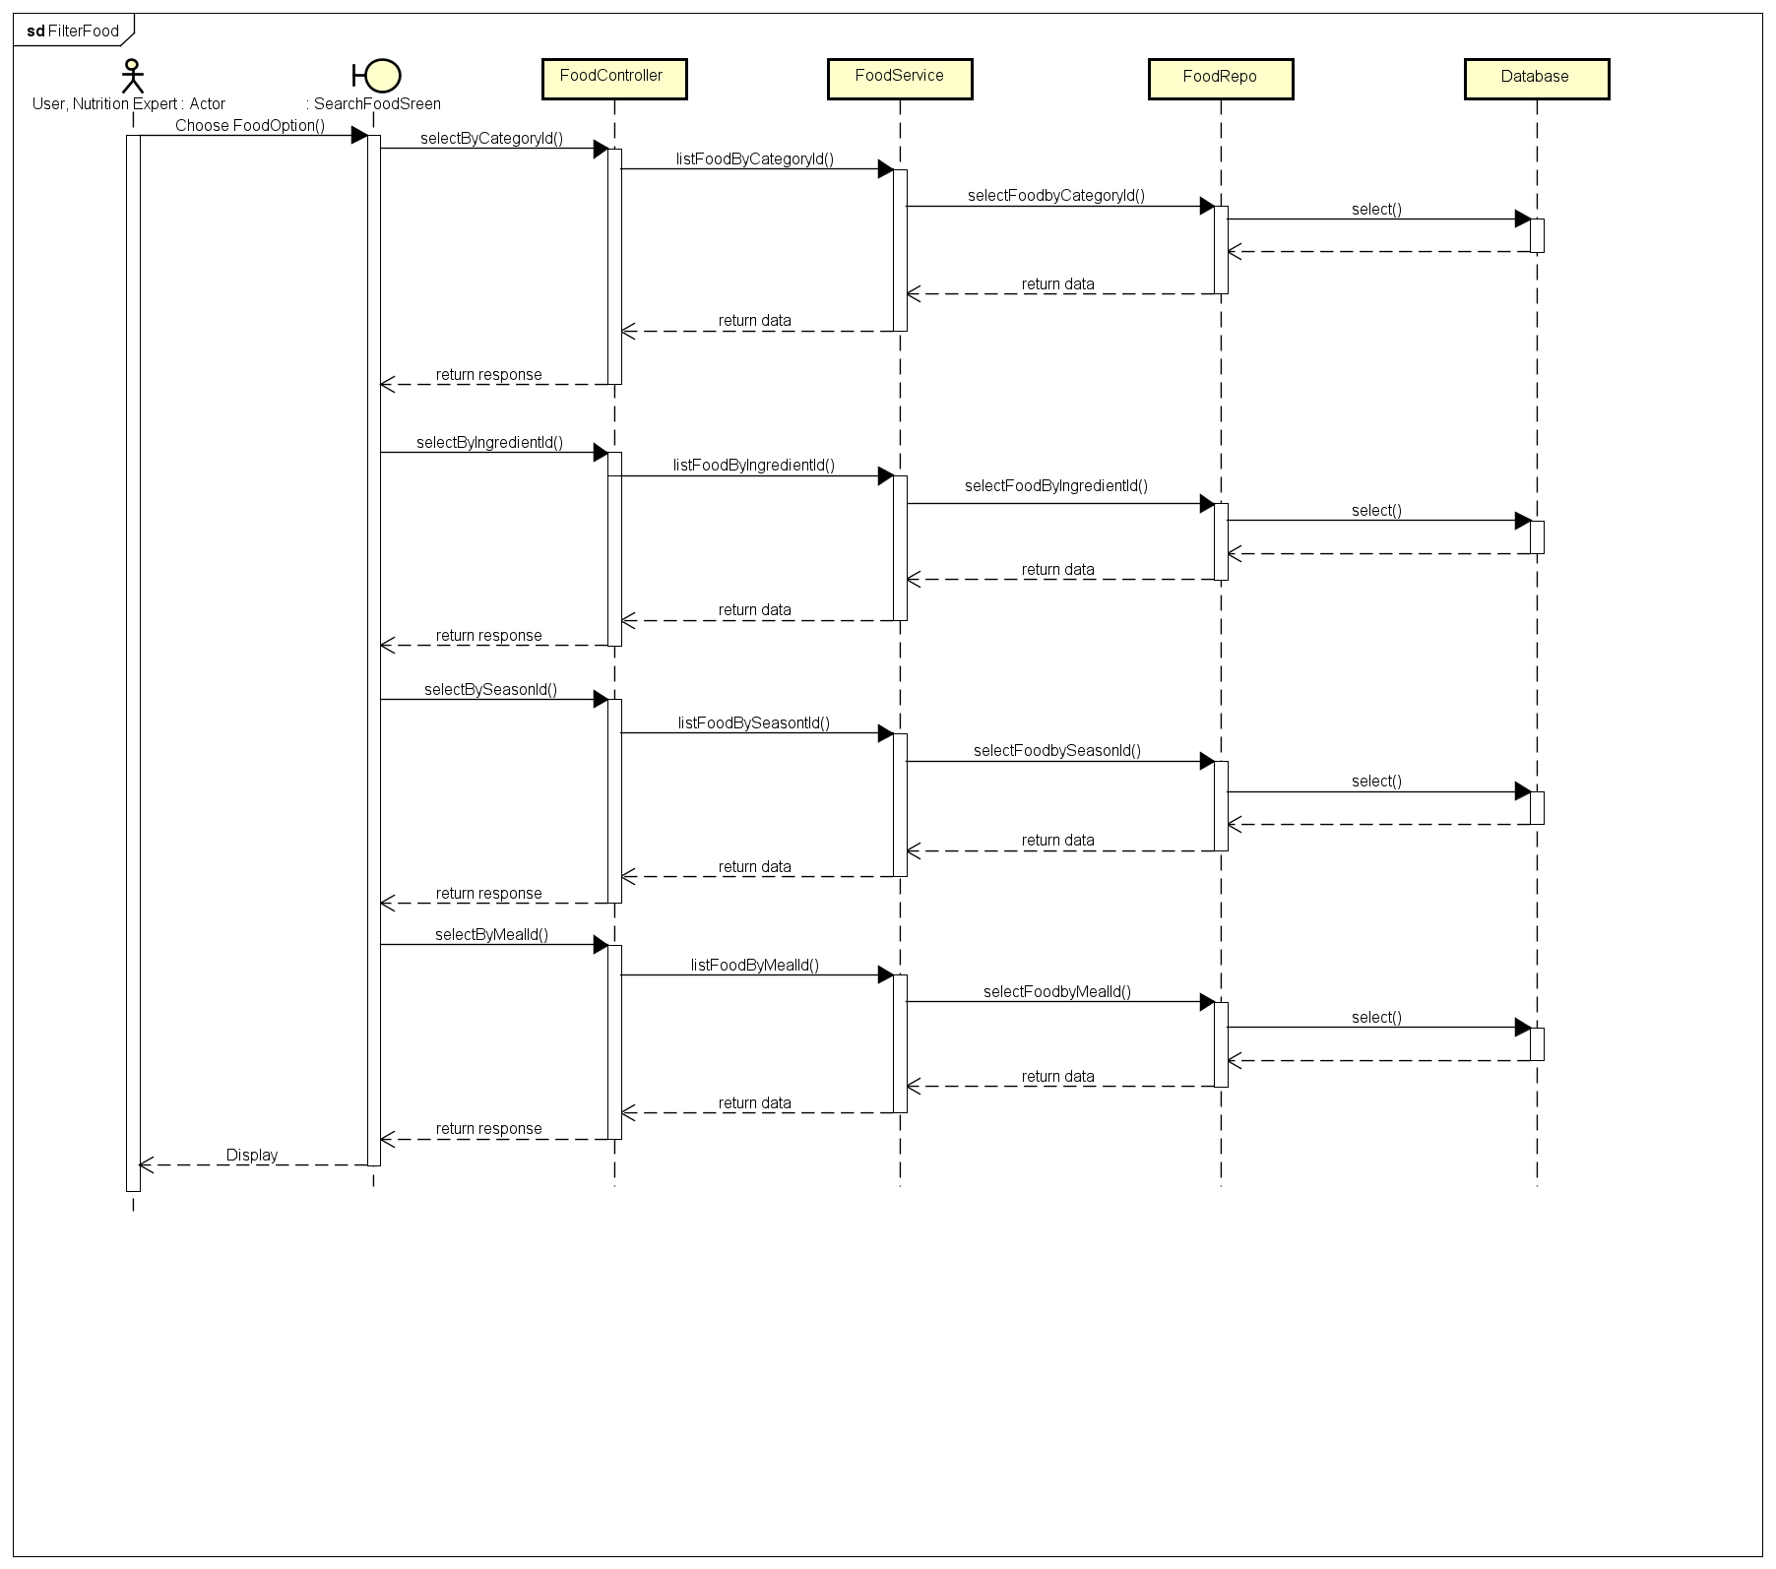

Figure 3.5.2.3. “” Sequence Diagram

##### 3.5.2.4. Filter Ingredient

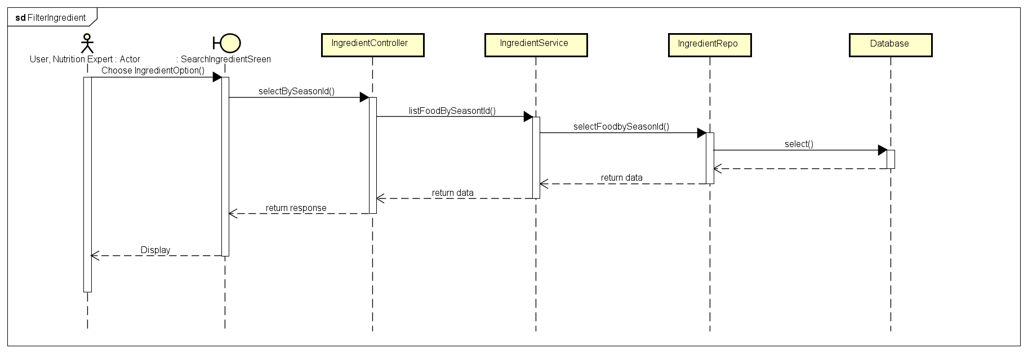

Figure 3.5.2.4. “Delete personal review” Sequence Diagram

##### 3.5.2.5. View Food Detail

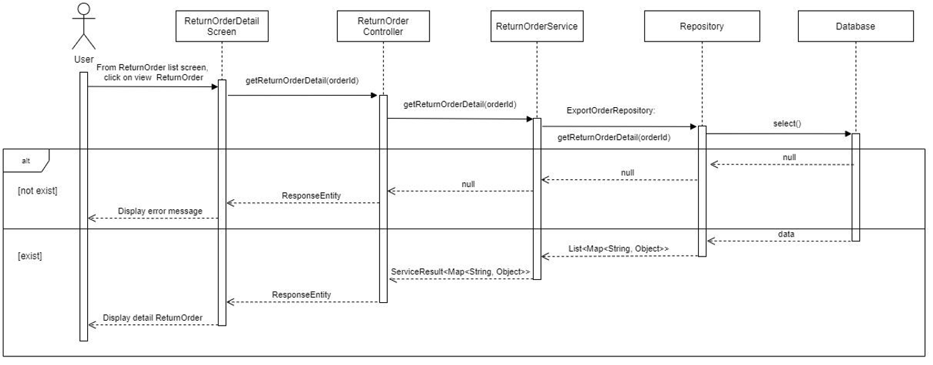

Figure 3.5.2.5. “View Food Detail” Sequence Diagram

### 3.6. Feature “Manage Diet”

#### 3.6.1. Class Diagram

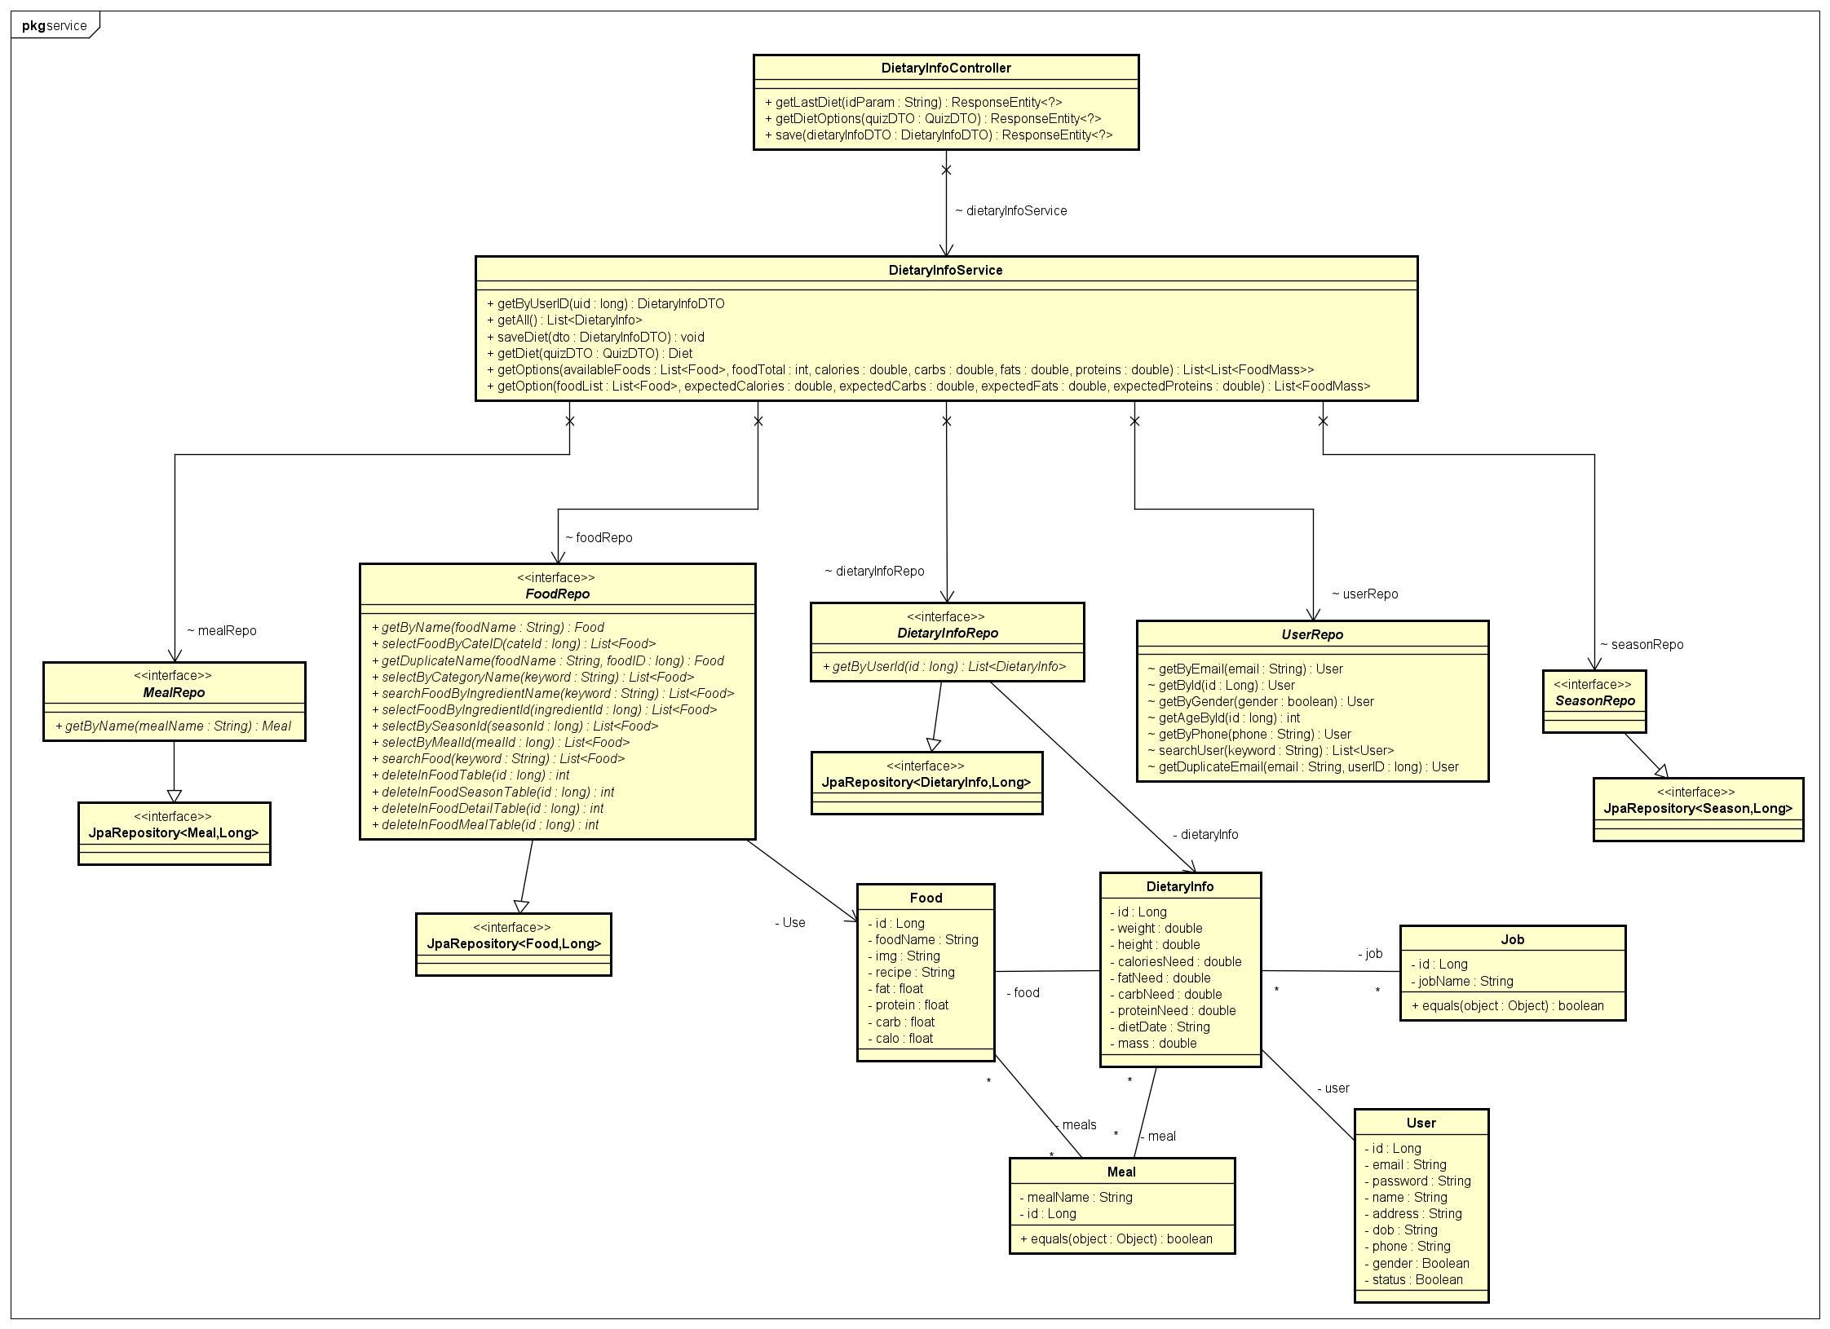

Figure 3.6.1. “Manage check-in” Class Diagram

#### 3.6.2. Sequence Diagram(s)

##### 3.6.2.1. Receive Diet

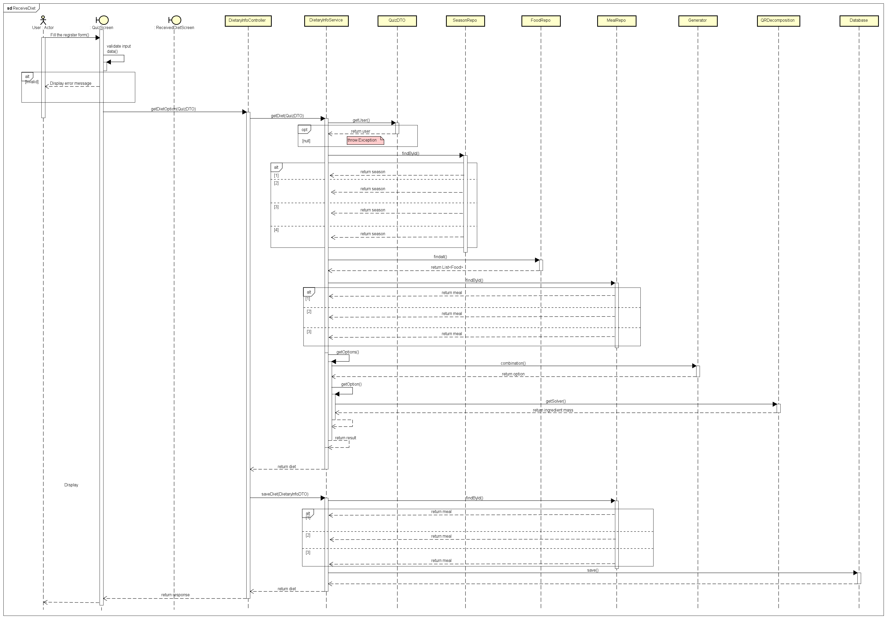

Figure 3.6.2.1. “” Sequence Diagram

##### 3.6.2.2. View Schedule

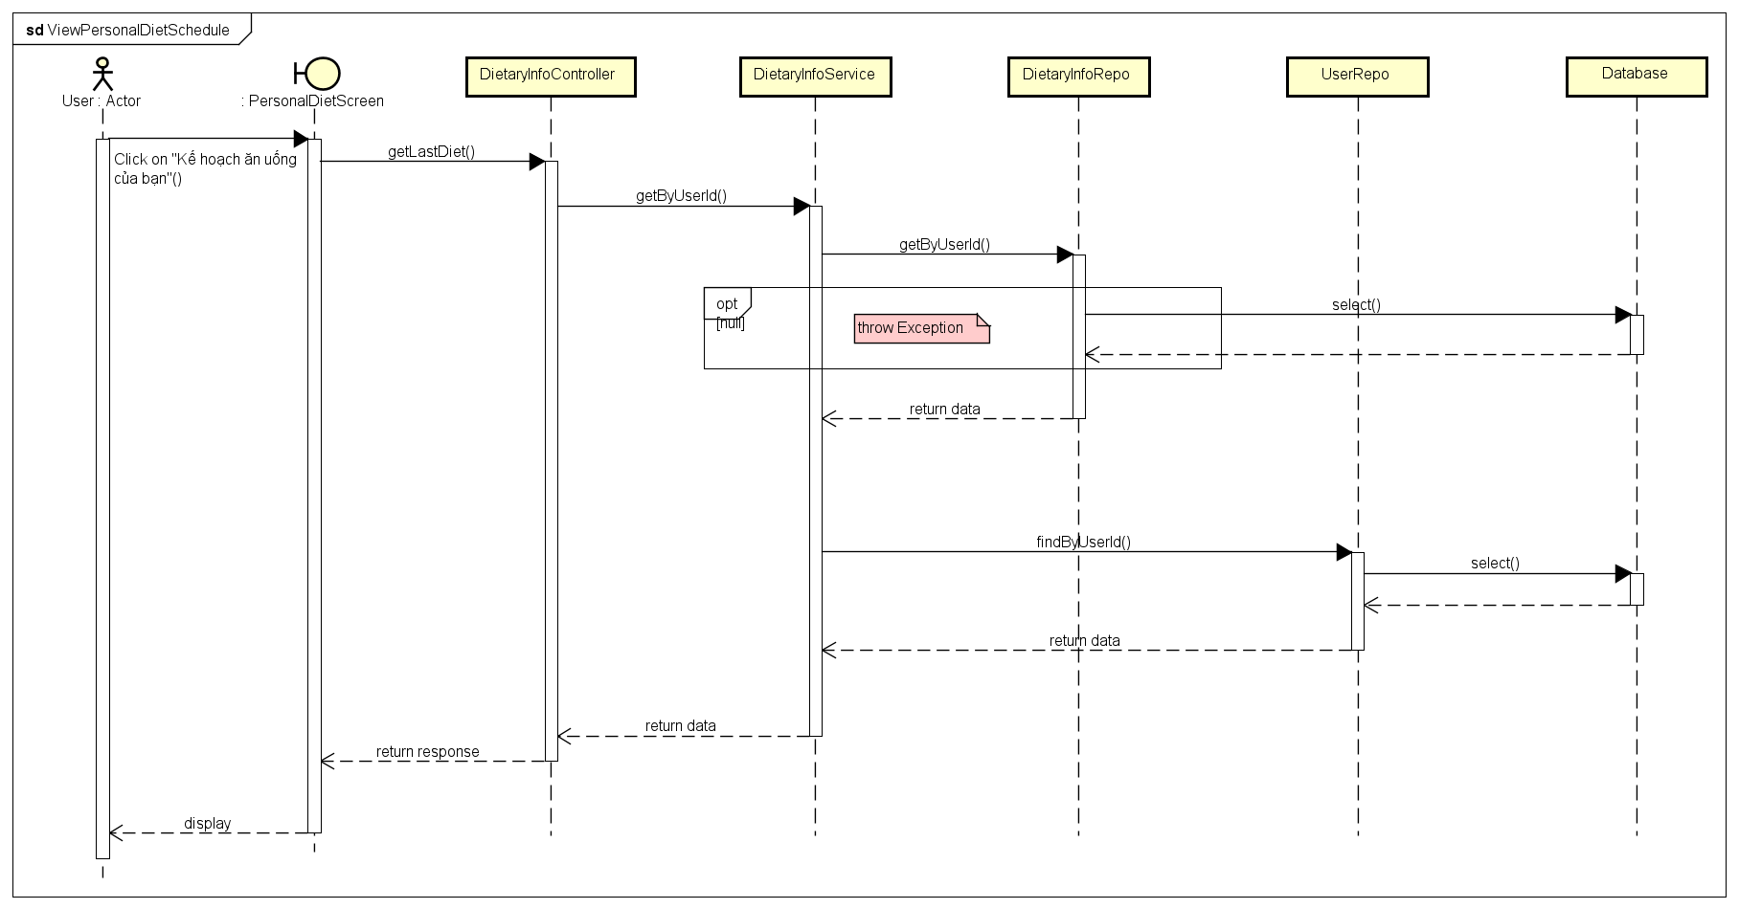

Figure 3.6.2.2. “View personal Schedule” Sequence Diagram

##### 3.6.2.3. Change Diet

Figure 3.6.2.3. “” Sequence Diagram

### 3.7. Feature “”

#### 3.7.1. Class Diagram

Figure 3.7.1. “Manage catch reports” Class Diagram

#### 3.7.2. Sequence Diagram(s)

##### 3.7.2.1.

Figure 3.7.2.1. “” Sequence Diagram

##### 3.7.2.2.

Figure 3.7.2.2. “” Sequence Diagram

##### 3.7.2.3.

Figure 3.7.2.3. “” Sequence Diagram

##### 3.7.2.4.

Figure 3.7.2.4. “” Sequence Diagram

##### 3.7.2.5.

Figure 3.7.2.5. “” Sequence Diagram

### 3.8. Feature “”

#### 3.17.1. Class Diagram

Figure 3.17.1. “” Class Diagram

#### 3.17.2. Sequence Diagram(s)

##### 3.17.2.1.

Figure 3.17.2.1. “” Sequence Diagram

##### 3.17.2.2.

Figure 3.17.2.2. “” Sequence Diagram

##### 3.17.2.3.

Figure 3.17.2.3. “” Sequence Diagram

1. [Spring Boot](https://spring.io/projects/spring-boot)
2. [JSON Web Tokens](https://jwt.io/)
3. [GitHub Actions](https://github.com/features/actions)